
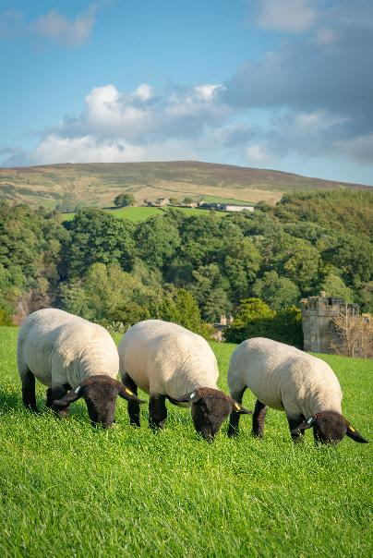
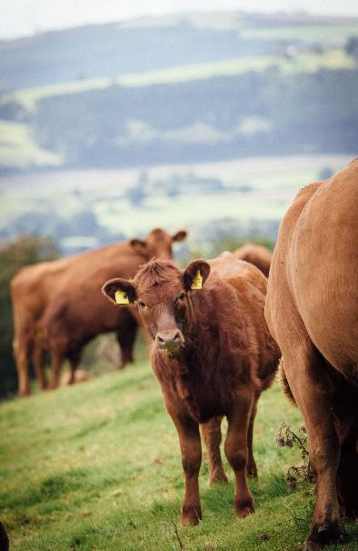


Delivering emissions reduction through efficient,
resilient production
July 2026

Contents

Contents 2
Supporting organisations 3
Executive summary 4
Foreword 6
Introduction by Andrew Loftus 7
Using the roadmap 11
A phased approach 13
Marginal Abatement Cost Curves 14
What is a MACC? 14
Evolution of UK agriculture MACCs 14
Reporting metrics 16
Updating the MACC 18
Mitigation measures modelled 18
Assumptions and caveats 19
What does the updated MACC tell us? 20
What the MACC does not address 24
Priority cost-saving mitigation measures 25
Optimising lifetime growth 25
Nutrition 34
Animal health 37
Genetics and breeding 42
Soil health (pH, compaction and drainage) 49
Grass–legume mixes 54
Improving nitrogen efficiency 57
Scaling beyond ‘cost-saving’ measures 61
Cross-cutting themes 65
Overcoming barriers and unlocking progress 70
Action plan 2026–2030 73

Supporting organisations

AHDB
ABP UK
Association of Independent Meat Suppliers (AIMS)
British Meat Processor Association (BMPA)
Dunbia
Meat Promotion Wales (HCC)
Kepak
The Livestock Auctioneers Association Limited (LAA)
Myton Food Group
National Beef Association (NBA)
National Farmers Union (NFU)
NFU Cymru
National Sheep Association (NSA)
OSI UK
Pickstocks Telford LTD
Prof Jude Capper (Livestock Sustainability Consultancy)

Any enquiries regarding this publication should be sent to us at:
AHDB
Siskin Parkway East
Middlemarch Business Park
Coventry CV3 4PE
Email: info@ahdb.org.uk

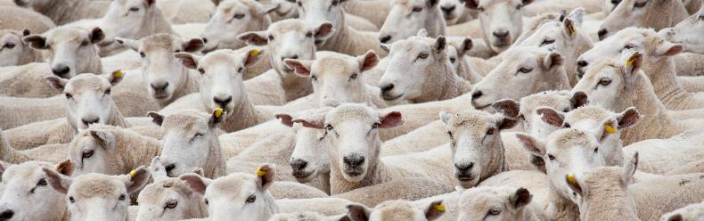

Executive summary

The Beef & Lamb Environmental Roadmap sets out how those sectors in England and Wales can continue improving environmental sustainability while maintaining productive, resilient and commercially viable farm businesses. This updated edition builds on the first roadmap published in 2025 and incorporates revised Marginal Abatement Cost Curves (MACCs), updated adoption assumptions and further stakeholder input.
The roadmap focuses initially on reducing greenhouse gas (GHG) emissions through measures that are technically robust, practical to implement and estimated to be economically neutral positive. The emphasis is on interventions that strengthens biological and resource efficiency, improves resilience and can be widely adopted under current farming conditions.
The updated MACC analysis separates beef into suckler and dairy beef systems, resulting in three distinct pathways: suckler beef, dairy beef and sheep. The modelling uses 2025 as the baseline year and assumes broadly stable agriculture activity through to 2050.
Under the modelled adoption of the no-regrets measures, annual GHG emissions in 2050 could be reduced by 1.9 Mt CO2e, equivalent to 7.9% across the three sectors combined. This comprises approximately
0.74 Mt CO2e in sheep (-12%), 0.28 Mt CO2e in dairy beef (-5%) and 0.93 Mt CO2e in suckler beef (-7%). These reductions represent a pragmatic first phase of action rather than the full mitigation potential of
the sector.

Important interpretation note
The 7.9% reduction modelled in this roadmap:
- Assumes realistic rather than universal adoption
- Excludes most additional cost-technologies
- Excludes most sequestration
- Excludes many emerging technologies
- Assumes stable production
Indicative analysis suggests substantially greater reductions may be achievable over time through wider adoption, innovation, investment and supply chain decarbonisation.

The modelling indicates that meaningful progress can be achieved through improvements in animal health and productivity, forage quality and nutrition, soil management, nutrient efficiency, breeding and genetics and grassland management. Most of these measures improve emissions intensity while also strengthening productivity and resilience.
Methane remains the dominant greenhouse gas across all three sectors, accounting for approximately
72–78% of baseline emissions. However, the modelling demonstrates that substantial mitigation also arises from reductions in soil nitrous oxide and embedded fertiliser emissions, highlighting the importance of nitrogen efficiency and forage management alongside methane reduction.
The roadmap adopts a whole-system perspective that includes Scope 3 emissions associated with inputs such as fertiliser and feed. This aligns the roadmap more closely with emerging supply chain reporting frameworks and science-based targets used by retailers and processors.
The measures modelled are intentionally conservative. Further reductions are likely to come from:
- Greater uptake of existing measures
- Additional-cost technologies such as inhibitors and feed additives
- Supply chain decarbonisation
- Improved evidence on sequestration
- Emerging technologies and innovation
- Indicative analysis suggests that these additional pathways could deliver further substantial reductions beyond the 7.9% modelled in this phase
The roadmap also recognises several important areas of uncertainty, including methane-accounting methodologies, sequestration measurement and definitions, farm-level data quality and evolving reporting frameworks. These issues do not prevent progress, but they reinforce the need for continued evidence development, transparent reporting and improved baseline data, as well as the continued evolution of carbon accounting policy and standards.
Finally, the roadmap recognises that reducing emissions intensity and reducing absolute emissions are related but not identical objectives. Many of the measures identified improve productivity and reduce emissions per kilogram of output, which represents meaningful environmental progress. Future roadmap iterations will continue to assess both intensity and absolute emissions while maintaining a balanced view
of environmental improvement, food production, sector resilience and the risk of emissions displacement.
The roadmap should therefore be understood as a living framework, a technically grounded and economically realistic basis for action now, while recognising that science, policy, markets and available technologies will continue to evolve.
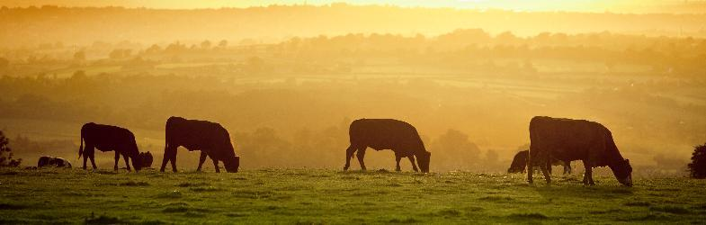

Foreword

As a farmer, I know that beef and lamb producers are already managing a complex set of challenges: volatile markets, changing policy, extreme weather, labour pressures and the need to maintain productive, profitable businesses. At the same time, there is growing expectation on our sectors to demonstrate environmental progress and show how we are reducing emissions while continuing to produce high-quality food. This roadmap is an important step in setting out a practical, evidence-led pathway for the beef and lamb sectors in England and Wales. It focuses first on measures that make sense for farm businesses: healthier animals, better growth, improved genetics, stronger soils, better forage and more efficient nutrient use. These are not abstract environmental concepts; they are the foundations of productive, resilient farming systems.
I would like to thank the Technical Steering Group for their time, expertise and constructive challenge throughout this process. In particular, I would like to recognise Andrew Loftus for his leadership as Chair of the Technical Steering Group and for helping to ensure that the roadmap remains technically robust, balanced and grounded in the realities of beef and sheep production. I am also grateful to the many organisations and individuals who have contributed evidence, insight and practical experience. This roadmap reflects a collective effort across the sector and shows what can be achieved when farmers, processors, levy bodies, researchers and wider industry partners work together.
The roadmap should be seen as a living framework. It does not ask every farm to follow the same route, but it does provide a clear direction of travel. By focusing on practical improvements that support both environmental progress and business resilience, the beef and lamb sectors can demonstrate leadership, maintain confidence and help shape their own future.
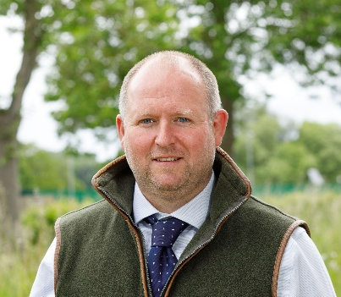
George Fell
Chair, Beef & Lamb Environmental Roadmap Governance and Ownership Group
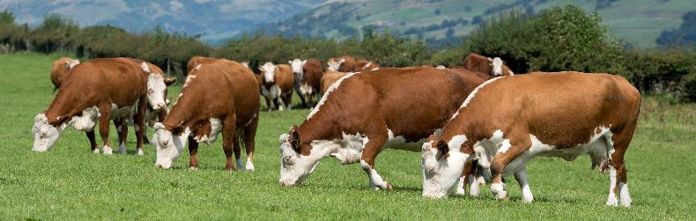

Introduction by Andrew Loftus
By Andrew Loftus, Beef and Lamb Environmental Roadmap Technical Steering Group Chair

Tackling climate change is one of the most pressing global issues of our time, and the next decade will be critical for action across the whole economy, including agriculture. The UK is a signatory to the Paris Agreement which seeks to limit the global temperature rise to 1.5°C and this commitment is reflected in UK law through the Climate Change Acts. The UK is committed to reducing economy-wide greenhouse gas (GHG) emissions by at least 81% by 2035, compared to 1990 levels, aligning with the Climate Change Committee’s (CCC) sixth carbon budget (2033–37) on the pathway to reaching net zero by 2050. While no formal sectoral target has been set for UK agriculture, the CCC has published non-binding sectoral pathways, which were accepted by Government in June 2026.
For agriculture, Article 2 of the Paris Agreement is particularly significant because it requires signatories to lower net GHG emissions in a manner that “does not threaten food production”.1 This provision has not been transposed into domestic law, with the partial exception of Northern Ireland, where “the special economic and social role of agriculture, including the distinct characteristics of biogenic methane” are recognised in the Climate Change Act (Northern Ireland) 2022, which specifically exempts agricultural methane from reductions “more than 46% lower than the [1990] baseline”.
At the UK level, domestic food production and food security do not benefit from any legal protection in the same way as emissions reduction targets. Furthermore, both the sixth and seventh carbon budgets assume significant cuts in ruminant livestock numbers.2, The CCC’s ‘Balanced Pathway’ requires a reduction of 27% in cattle and sheep numbers between 2023 and 2040 alongside the re-purposing of agricultural land to tree planting.4
Against this background, this roadmap seeks to outline a route for the English and Welsh beef and lamb sector to work towards net zero by 2050, alongside other environmental goals, in a way that does not threaten UK food production and ensures the economic sustainability of the sector. It has a primary focus on climate change due to the UK’s legal obligations under the Climate Acts. Other important aspects of environmental protection, such as nature, biodiversity and water will be considered in future iterations.
In 2022, agriculture was estimated to account for 12% of total UK GHG emissions within the National Inventory†. This includes 49% of all UK methane emissions, almost all of which arise from ruminants and 70% of nitrous oxide emissions but only 2.3% of total UK CO₂ emissions. By contrast, CO₂ is the predominant GHG in almost all other sectors of the economy.
British beef and lamb production is predominantly extensive and grass based, which is not the case in all major beef and lamb producing regions elsewhere in the world. Most global and regional comparisons suggest UK beef and lamb production performs relatively well, with GHG emissions one-third lower than the global average.,
Despite this, ruminant-derived foods are often described as relatively ‘high-carbon’ choices, often without consideration of their equally high nutritional value. This perception, together with substantial political, environmental and ethical pressures, is now challenging the reputation of beef and lamb, with an increased demand for change. Given the enduring popularity of red meat among consumers, this pressure is perhaps more likely to be felt through regulatory interventions rather than consumer choice.
At a departmental level, Defra is responsible for delivering progress towards net zero in agriculture under the Climate Acts, via its contribution to the ‘Carbon Budget and Growth Delivery Plan’ published in October 2025. Previous Defra delivery plans have been successfully challenged by NGOs in the courts under the Climate Acts, forcing the Government of the day to adopt more ambitious and/or robust emissions reduction policies. The ability to challenge government policy under the Climate Acts is an important development in public policy and similar challenges are likely in the future, limiting the freedom of government action in this area.
To rise to this challenge, the English and Welsh beef and lamb sector are working in multiple ways to simultaneously reduce environmental impacts while increasing productivity. To avoid regulatory intervention, allay consumers’ concerns and keep its place in future diets, this roadmap aims to show how the beef and lamb sector can contribute to the UK’s legally binding target of net zero by 2050 without sacrificing production or economic sustainability.
This document sets out what the sector has already achieved, what it can achieve in the future and signposts important areas for further research and development. Any route to net zero requires the development and evaluation of emissions mitigation or abatement strategies. The roadmap process explores the most likely pathways to deliver climate goals while recognising the diversity of farm systems in England and Wales, the limitations of current scientific knowledge and economic realities.
Any credible route to net zero depends on understanding which mitigation measures are effective, practical and scalable. For this reason, AHDB commissioned new work from SRUC focused on seven of the most well-developed ‘no-cost’ or ‘cost-neutral’ mitigation measures available to the sector. These are measures that can be achieved at zero net cost on most farms, and in some cases enhance productivity, resilience and long-term farm profitability.
Of course, ‘no-cost’ measures which are well understood, technically robust on current scientific knowledge and productivity enhancing/neutral only take us part of the way to achieving the sectors’ goals. In this roadmap we show how such measures can deliver an estimated 1.9 Mt CO₂e‡ (7.9%) reduction in emissions by 2050 across the suckler beef, dairy beef and sheep sectors with no loss of production or profitability. While this is an important and significant step on the journey toward our goals, further reductions will be necessary.
This is likely to be achieved in the following ways:
- Higher uptake of ‘no-cost’ measures beyond current adoption levels (estimated additional mitigation: ~3.5%)
- Additional cost measures using proven technologies such as inhibitors, feed additives and improved manure management (estimated mitigation: ~3.7%)
- Decarbonised supply chains, particularly feed sourcing and fertiliser manufacture (estimated mitigation: ~3%)
- On-farm sequestration, including soil carbon and vegetation management, where current estimates vary but potential is likely significant
- Emerging technologies, such as on-farm dietary manipulation, bio-actives, methane suppressants
Cumulatively these further measures are estimated to deliver a 10.2% (2.45Mt CO₂e) reduction (additional
to the 7.9%, 18.1% cumulative (4.35 Mt CO₂e)) before sequestration and emerging technologies are
factored in.

Methane
Reductions in enteric methane emissions from rumination represent a large share of the modelled emissions reduction. Under GWP 100, they account for around 40% of the total CO2e reduction. However, GWP100 is not well suited to estimating the cumulative climate effect of sustained changes in short-lived climate forcers (SLCF) such as methane or the resulting warming at a given point in time, such as 2050. More recently developed step- or pulse-based metrics, sometimes referred to as ‘warming-based’, including GWP*, are better suited to estimate the climate effect of sustained increases or decreases in the rate of methane emissions.
In simple language, methane behaves differently from carbon dioxide and nitrous oxide because it is a short-lived gas. A sustained decrease in the rate of methane emissions has a similar effect to removing historic carbon dioxide from the atmosphere because it reverses much of the warming caused when that rate was increased in a relatively short period of time. This is not the case for carbon dioxide or nitrous oxide. For those gases, reducing the rate of emissions lowers future warming, but it does not reverse past warming unless the emission is actively removed through sequestration or an equivalent mechanism.
At a national level, applying warming-based metrics to a sustained decrease in agricultural methane emissions is relatively straightforward. When Teagasc remodelled the projected emissions reductions from Irish agriculture to 2050 using GWP*, an emissions reduction of 2.9 MtCO₂e under GWP100 translated to 8.3 MtCO₂we§ under GWP*. In effect, the methane component of the reduction was valued at around 3.5 times higher under the warming-based approach. On the same basis, a 4.35 Mt CO₂e reduction in UK beef and lamb emissions to 2050 would equate to around 8.7 Mt CO₂we.
Applying GWP* to baseline emissions or at the individual farm level remains technically challenging, and further development of warming-based metrics is required. Nevertheless, this should not detract from the central point that GWP100 significantly understates the climate impacts of sustained reductions in methane emissions such as those modelled in this roadmap and therefore undervalues the contribution of these reductions in the fight against climate change. Logically, therefore, using GWP100 does not simply understate the contribution of methane mitigation – it also reduces the incentive for methane mitigation (which is required regardless of choice of metric).

Farm data
The first iteration of the roadmap identified three cross-cutting themes that will shape progress. Alongside GHG metrics, and the importance of sequestration, the availability of high-quality farm data was also identified as a limiting factor in further reduction efforts.
Farm-level data offers important advantages over broad averages. It helps individual farming businesses better understand their own emissions/impact profile and deploy more relevant mitigations. It also enables modellers to define baselines more accurately and assess the realistic scope for further improvement.
There is considerable variation between farm carbon calculators. But regardless of which tool is used, there is also very wide variation in emissions intensity between farms. In ABP’s PRISM work, results ranged from less than 10 to more than 100 KgCO₂e per kg of deadweight. This variance needs to be better understood. It may be that greater emissions savings are possible by reducing this variation than the MACC model suggests. Ultimately this is a question about the accuracy of the ‘baseline’ used in some modelling. Where, within this wide range, does the true UK average sit?
SRUC identified specific areas of data uncertainty within their modelling. One important example is the lack of high-quality farm level data on feed. We do not yet have a sufficiently clear picture of the average UK ruminant diet, how nutritious it is, how it varies and how much cattle and sheep eat in practice. This is difficult to measure because ruminant systems are highly variable and cattle and sheep are valued precisely because they can convert a wide range of feeds, forages and grazing into high-quality protein. However, improving this evidence base would strengthen both emissions modelling and practical decision making. As SRUC noted, “the collection of a set of representative farm data would be possible and could greatly improve both the GHG inventory and the MACC modelling.”
It may be the case that some of the data and modelling now driving policy development is being stretched well beyond its original purpose and suitability. We have highlighted areas where this uncertainty can be reduced in our Action Plan.
Finally, on a personal note, I’d like to thank AHDB and all those stakeholders who have contributed so thoughtfully to this process. I hope and believe this roadmap will prove a useful step forward on our journey to a beef and lamb sector which is both stronger and more sustainable.
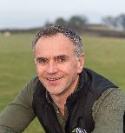
Andrew Loftus
Chair, Beef & Lamb Environmental Roadmap Technical Steering Group
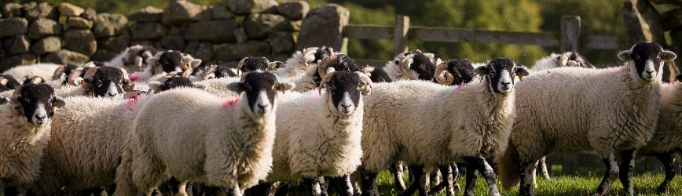

Using the roadmap

The roadmap is designed as a strategic evidence base for the beef and lamb sectors in England and Wales. It is not intended to act as a standalone farm advisory manual, as the most appropriate actions will vary by system, land type, enterprise structure, market outlet and starting point. For farmers, a shorter summary sits alongside the full roadmap to translate the key messages into more accessible, practical actions.
For farmers, the roadmap can be used to:
- Understand the main sources of emissions and environmental impact within beef and sheep systems and what sorts of change are likely to be necessary
- Identify specific low-cost mitigation measures relevant to their own system and circumstances
- Consider where actions that improve environmental performance may also enhance productivity, resilience and long-term profitability
- Support informed conversations with other farmers, advisers, processors and supply chain stakeholders
For advisers, levy bodies and industry organisations, the roadmap provides:
- A shared evidence base to guide advice, investment and programme design
- Insight into priority measures, likely adoption challenges and where targeted advice, demonstration or financial support can help accelerate adoption
For processors, retailers and policymakers, the roadmap offers:
- Greater transparency on where emissions reductions can realistically be achieved, over what timescales and at what level of investment
- A basis for designing incentives, standards and reporting approaches that are proportionate and grounded in farm-level reality
- A common reference point to support consistent messaging and coordinated action across the supply chain
Importantly, the roadmap is designed to guide strategic progress, not to define specific outcomes at farm level. Not every measure will be suitable for every farm, and there is no single pathway to reduce environmental impacts.
The roadmap will continue to evolve as new evidence, technologies and data become available. Readers are encouraged to use it as a living framework to prioritise actions, test what works in practice and contribute to future iterations that strengthen both environmental outcomes and business resilience in the beef and lamb sectors. Input from farmers, advisers and supply chain stakeholders will be important in shaping future updates.



A phased approach

Reducing emissions in beef and lamb production requires a defined series of steps or plan. Not all mitigation measures carry the same level of technical certainty, cost profile or system impact. For this reason, the roadmap adopts a staged approach.
The first phase focuses on improving biological and resource efficiency, measures that are well understood, technically robust and cost saving or cost neutral for most farms. These actions should strengthen productivity and resilience while delivering measurable reductions in emissions intensity. Prioritising efficiency provides a stable foundation for further change.
The second phase centres on accelerating adoption. Evidence shows that performance varies significantly between farms, indicating that closing the gap through wider uptake of existing best practice could unlock additional mitigation.
Over time, further change will be required. This includes the integration of proven additional cost technologies, supply chain decarbonisation, improved evidence on sequestration and better ways of accounting for the nuanced role of methane emissions. These elements depend on evolving economics, infrastructure and regulation clarity.
Placed in context, this staged approach reflects realities facing farmers, volatile markets, policy reform and increasing climate variability. It recognises that meaningful progress must be credible, commercially visible and grounded in production systems that continue to deliver high-quality British beef and lamb.

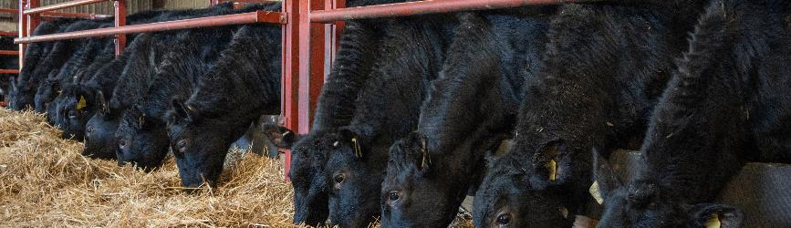

Marginal Abatement Cost Curves
Addressing climate change in beef and sheep production requires clarity not only on what actions can reduce GHG emissions but also on which actions deliver the greatest benefit for farm businesses alongside environmental gains. Marginal Abatement Cost Curves (MACCs) provide this clarity by bringing together evidence on known mitigation options, their emissions-reduction potential and their likely costs or savings.

What is a MACC?
A MACC is a visual decision-support tool that ranks emission-reduction options according to their cost-effectiveness, showing both the scale of potential emissions reduction and whether a measure is expected, on average, to save money or require additional investment. The measures are ordered from lowest to highest cost, making it easy to see which actions can deliver the greatest emissions reductions at the lowest cost. It provides a simple way to prioritise where action can be most effective. For farmers and the wider supply chain, MACCs help identify ‘no-regrets’ actions that, on average, improve efficiency, resilience and profitability while also reducing emissions.

Evolution of UK agriculture MACCs
MACCs have long informed UK climate policy, particularly the Climate Change Committee (CCC) and Government in setting carbon budgets and designing delivery pathways. All UK agricultural MACCs to date have been developed by scientists and modellers at Scotland’s Rural College (SRUC).
Early CCC MACCs in the late 2000s established the first evidence-based estimates of agricultural abatement. Defra’s Clean Growth project and subsequent updates strengthened the evidence base and extended projections to 2050. More recently, seventh carbon budget and sector-specific MACCs have improved system precision.
In 2024, IGD, Ernst and Young (EY) and Waste and Resources Action Programme (WRAP) published the first sector-specific MACCs for beef and sheep. These represented a significant step forward by moving beyond national boundaries and adopting a ‘Scope 3 perspective’. Unlike a purely territorial approach, a Scope 3 lens reflects value-chain emissions rather than emissions confined within national boundaries. It incorporates embedded emissions from inputs such as fertiliser and feed and aligns more closely with supply chain expectations. Many downstream businesses are now setting science-based targets that extend beyond direct emissions and require emission reductions across their supply chain. Using a Scope 3 lens therefore ensures that mitigation opportunities are assessed in a way that better reflects how carbon performance is increasingly understood and measured across the supply chain, particularly by retailers and food businesses with downstream climate targets. Scope 3 insights are key to linking farm-level actions with downstream supply chain targets and commercial expectations.
Focusing solely on National GHG Inventory emissions (Scope 1 and 2) risks overlooking mitigation opportunities that may deliver substantial whole-system benefits, but which fall outside national accounting boundaries. A Scope 3 perspective therefore supports the roadmap’s aim of identifying the actions that deliver the greatest overall environmental benefit.
There is, however, a potential risk around competitiveness if UK production is judged against imports using different or narrower methodologies. In those circumstances, methodological differences could make it harder to demonstrate progress on a consistent basis. The scale of that risk will depend largely on how retailers and supply chains choose to measure, compare and value emissions performance. This makes transparency, consistency and clear methodological disclosure especially important.

A Scope 3 Perspective
Fertiliser
Fertiliser provides a clear illustration of the difference between the National GHG Inventory and value-chain accounting. Under a National GHG Inventory (Scope 1 and 2) lens, the benefits of optimising fertiliser use are primarily associated with reduced direct nitrous oxide (N2O) emission from soils following application, reduced indirect N2O emissions arising from volatilisation and leaching and lower diesel use from fewer spreading passes.
However, a significant proportion of fertiliser-related emissions occur during manufacture, which is energy intensive and often takes place outside of the UK. These embedded emissions are not captured within the UK’s National GHG Inventory. When fertiliser use is optimised and overall demand is reduced, emissions from fertiliser production also decline. This wider impact is captured within a Scope 3 framework.
Viewed through this lens, improving nitrogen use efficiency is not only about reducing on farm soil emissions. It also reduces upstream manufacturing emissions and lowers the embedded carbon associated with beef and lamb production.
This distinction is important. If the sector focuses solely on Scope 1 and 2 emissions, there is a risk of misalignment with the metrics driving commercial decisions. A Scope 3 perspective ensures that mitigation opportunities are assessed in a way that reflects both planetary impact and supply chain expectations, supporting continues market access while delivering meaningful emissions reductions across the value chain.

For beef, emissions are dominated by methane and nitrous oxide, with the IGD MACC indicating that around 15% of emissions could be reduced by 2050 relative to a 2021 baseline through the combined effect of both cost saving and additional cost technically feasible measures, assuming no change in UK production. The cost-saving measures improve biological and resource efficiency, while the additional cost measures can deliver further reductions but require additional capital or input costs (Table 1).
For sheep, emissions are mainly driven by methane and nitrous oxide. The MACC shows potential to reduce emissions by up to 13% by 2050, through both cost saving and additional cost mitigation (Table 2). For both beef and sheep, increased carbon sequestration is also likely to reduce net emissions, and new innovations, currently under development and not yet able to be accurately modelled, such as on-farm dietary manipulation, are likely to deliver further reductions.
Table 1. Cost-saving and additional cost mitigation measures for the beef sector
Cost saving | Additional cost
Soil compaction  Soil pH  Improved drainage  Genomics and breeding  Improved nutrition  Faster-finishing beef  Reducing nitrogen excess  Grass–legume mix  Lower emission breeding goal | Variable rate nitrogen application  Improved crop nitrogen use efficiency  Urease inhibitor  Nitrate feed additives  Biogas flaring  Anaerobic digestion  Alternative feed ingredients (e.g. triticale)  Impermeable slurry cover  Health  Cover crops  3NOP methane inhibitor  Slurry acidification  Nitrification inhibitor
Source: IGD, 2024
Table 2. Cost-saving and additional cost mitigation measures for the sheep sector
Cost saving | Additional cost
Soil compaction  Soil pH  Improved drainage  Genetics and breeding  Reducing nitrogen excess  Grass–legume mix  Health | Improving nutrition  Cover crops  Nitrification inhibitor  Variable rate nitrogen  Improved crop nitrogen use efficiency  Urease inhibitor
Source: IGD, 2024

Reporting metrics
GWP100 is the primary reporting metric required by the UNFCC, although additional metrics are also permitted. It is also permitted to use no ‘metric’ at all, i.e. to report emissions in native tonnes of the constituent GHGs, usually referred to as ‘split gas’ reporting, rather than combining them into a single measure. GWP100 is used within the UK National GHG Inventory and under the UNFCC framework. Its use ensures consistency with national GHG reporting, government carbon budgets and wider policy environment in which the beef and lamb sector operate. GWP100 is designed to assess warming impact over a 100-year timescale.
Methane is a short-lived climate pollutant with different warming characteristics to long-lived gases such as carbon dioxide. Alternative metrics, based on ‘warming equivalence’ (including GWP*), have been developed to better reflect the warming impact of changes in methane emissions over time. These approaches can alter the relative weighting of gases within the combined measurement and may influence the sequencing or priority of mitigation measures.
Whichever metric is used, if at all, reducing methane emission delivers climate benefit. Different metrics may re-order priorities or change the framing of ambition, but mitigation actions that improve efficiency and reduce methane emissions are generally desirable under any metric. The only exception to this ‘rule’ is where methane reductions are achieved by increasing emissions of other gases, in which case unintended warming consequences may result depending on the timescale considered. For example, a strategy that reduces methane by feeding more concentrate and finishing animals earlier may still lead to unintended warming consequences if it increases emissions of nitrous oxide or carbon dioxide elsewhere in the system, such as through fertiliser use or feed production.
However, there is broad scientific consensus that reducing methane emissions delivers climate benefit under any recognised metric. While different methodologies may re-order priorities or change the framing of ambition, mitigation actions that improve efficiency, reduce methane intensity and lower absolute emissions remain meaningful across both GWP100 and alternative approaches.
The roadmap recognises that there is ongoing scientific discussion in this area and will continue to monitor developments. The overall direction of travel of improving biological efficiency and reducing emissions is broadly consistent regardless of metric choice.

Important note: GHG metrics
Emissions in this roadmap are reported using GWP100, in line with current inventory and reporting conventions. This supports consistency and comparability, but it is important to note that GWP100 does not fully reflect the warming behaviour of methane as a short-lived climate pollutant. This is particularly relevant for beef and sheep systems, where methane is a significant component of total emissions.
GWP100 is the standard way of converting different GHG into a common unit over a 100-year timeframe. It is widely used in national inventories and carbon reporting.
GWP* is an alternative approach designed to better reflect the warming effect of short-lived gases such as methane.
The choice of metric can affect how the climate benefit of methane reductions is valued. Under GWP100, methane reductions are important, but warming-based metrics such as GWP* may place greater emphasis on sustained reductions in methane over time.
Practical example
A measure that improves growth rate and reduces lifetime methane emissions, such as earlier finishing, may appear more valuable under a warming-based metric than under GWP100. By contrast, measures that reduce nitrous oxide, such as improving nitrogen use efficiency, remain important under either approach. The choice of metric may therefore influence how mitigation priorities are framed, even where the underlying actions remain beneficial in both cases.

Updating the MACC
The updated MACC for the Beef & Lamb Roadmap builds on the original IGD MACC analysis for beef and sheep, which provided a comprehensive assessment of GHG mitigation measures across the production cycle and identified a wide range of technical interventions, with varying abatement potential and cost profiles.
Following a review of the IGD MACCs, the Beef & Lamb Environmental Roadmap Technical Steering Group agreed that the updated analysis should prioritise measures that are cost saving or cost neutral to producers in the first instance. This reflects both the current financial pressure facing the sector and recognises that adoption at scale is most likely where environmental improvements align with business resilience and productivity gains.
The IGD analysis highlights that a substantial proportion of emissions reduction potential sits within efficiency-driven measures. However, the original curve combined beef systems. This updated MACC therefore separates beef into suckler and dairy beef systems, producing three distinct MACCs (suckler beef, dairy beef and sheep). This refinement improves system specificity, enhances transparency of the GHG breakdown and provides clearer visibility of where emissions reduction are achievable within each system. In doing so, it strengthens prioritisation of actions within the roadmap and supports more targeted decision making.
In addition, the Technical Steering Group undertook an assessment of feasible adoption rates to 2050 for each mitigation measures, drawing on industry experience, existing uptake data and practical delivery constraints. These assessed adoption trajectories form the bases of the uptake assumptions used within the modelling (see Annexe 1). This ensures that projected abatement reflects realistic on-farm delivery potential rather than assuming the universal adoption of every measure, providing a more credible and evidence-based pathway for the sector. Assuming universal adoption implies that every farm is technically suited to the measure, financially able to implement it, confident in the evidence, supported by advice, aligned with supply chain incentives and can operate within a system that makes change straightforward. In practice, those conditions rarely exist. Furthermore, farms differ widely in system type, scale, geography, soil, infrastructure, labour availability and appetite for risk.
For example, the potential to improve grassland productivity through drainage, reseeding or clover establishment may be much greater on some farms than others. A dairy beef system on productive lowland soils, with good access to technical advice and performance data, may be better placed to adopt and benefit from such measures than a suckler system on heavier or marginal land, where soil conditions, capital constraints or lower data availability may limit feasibility. Similarly, some producers may already be close to current best practice, while others face more fundamental barriers to change. Recognising this variation is essential to producing adoption assumptions that are grounded in practical delivery rather than theoretical maximum potential.

Mitigation measures modelled
The updated MACC includes a mix of sector-specific and cross-cutting measures (Table 3). For beef systems, these cover breeding, growth, health and land management interventions. For sheep, they include breeding, health and the same core land-management measures. Many of the soil and nutrient measures are cross cutting and apply across suckler, dairy beef and sheep, while breeding and nutrition measures are more sector specific.

Table 3. Mitigation measures modelled by sector
Mitigation measure | Suckler beef | Dairy beef | Sheep
Lower-emission breeding goal | Yes | Yes | No
Sheep breeding tools/non-core traits | No | No | Yes
Increasing liveweight gain | Yes | Yes | No
Improved health | Yes | Yes | Yes
Improved nutrition | Yes | Yes | No
Reducing soil compaction | Yes | Yes | Yes
Improving soil pH | Yes | Yes | Yes
Improving drainage on mineral soils | Yes | Yes | Yes
Reducing excess nitrogen application | Yes | Yes | Yes
Grass–legume mix | Yes | Yes | Yes

Assumptions and caveats
To enable fair comparison between mitigation measures, the modelling applied a common baseline and a consistent set of assumptions across all options.
The modelling uses 2025 as the baseline year. At UK level, total mitigation is estimated by comparing emissions in the baseline year with emissions after each measure is applied.
To ensure comparability between measures, the model assumes that overall agricultural activity remains broadly constant through to 2050, with livestock numbers, land area and yields held broadly stable. This is not intended to predict how the sector will develop in practice, rather it provides a clear and consistent basis for assessing the relative effect of different mitigation measures.
It should be noted that the MACCs are not derived by simply summing the standalone abatement potential of each measure. Measures are initially assessed independently, but where interactions occur, adjustment factors are applied so that the mitigation effect of lower-ranked measures is reduced accordingly. Mutually exclusive measures are also assumed not to deliver additional mitigation when implemented together. This approach helps account for overlap between measures and reduces the risk of double counting within the set of measures included in the analysis.
However, the measures assessed represent only a subset of the wider range of mitigation options available to the sector. The MACCs therefore do not capture all possible future interaction effects, particularly where additional measures or technologies are layered in beyond those modelled here. For that reason, they should be interpreted as a realistic prioritisation of the defined no-regrets measures, rather than a full representation of every possible whole-farm mitigation package.
In reality, the sector will continue to evolve over time in response to factors such as policy, markets, technology and global demand. The modelling also includes expected ongoing genetic improvement in suckler systems, reflecting the productivity gains that are likely to continue over time and the associated reduction in emission intensity.

What does the updated MACC tell us?

Important interpretation note
The reductions presented in this chapter do not represent the full mitigation potential of the beef and lamb sector to 2050. They reflect only the subset of measures assessed as cost saving or cost neutral to producers and judged most feasible for widespread uptake under current conditions.
This was a deliberate choice by the Technical Steering Group to focus first on measures most likely to be adopted at scale in the near term. The figures should therefore be read as a pragmatic starting point for action, not the ceiling of what may be achievable. Additional reductions will come from wider practice change, improved uptake, innovation, supply chain decarbonisation and measures requiring further investment or enabling support.
Also note that the quantified reductions shown below (both absolute and percentage reductions) are relative to the SRUC MACC baseline, not the National Inventory figures for UK agriculture (which are not produced n a Scope 3 basis).
Under the new modelled adoption of 11 mitigation measures, annual GHG emissions in 2050 could be reduced by 1.9 Mt CO₂e (7.9%) across all three sectors combined; this is approximately 0.74 Mt CO₂e in sheep (-12%), 0.28 Mt CO₂e in dairy-beef (-5%) and 0.93 Mt CO₂e in suckler beef (-7%) (Figure 1). By 2030, mitigation is estimated to reach just over half of these values, reflecting gradual uptake over a 15- to 20-year period (Figure 2) from a baseline year of 2025.
Across all three sectors, the single largest source of abatement is the adoption of grass–legume mixed swards, which reduce on-farm nitrous oxide emissions and nitrogen fertiliser use, including associated embedded emissions from fertiliser manufacture.
It is important to note what is not included in this estimate. The modelling does not account for potential effects of forage composition on rumen function and methanogenesis as this remains an area of emerging research. Nor does it include additional carbon sequestration from deeper rooting systems, reflecting the scientific and regulatory uncertainties outlined in the sequestration section.
In sheep systems, improved animal health represents the second-largest mitigation opportunity, with potential to reduce emissions by around 4% by 2050, while breeding for non-core traits (e.g. feed intake, methane yield) delivers additional cumulative savings of around 2%. The modelling may underrepresent the full mitigation potential associated with improved lamb survival and reduce neonatal mortality, which remain important drivers of emission intensity in sheep systems.
In beef systems, the most significant measures after grass–legume swards are improved animal health and increased liveweight gain, with larger relative benefits in suckler herds due to the high emissions contribution from breeding cows and replacement heifers.
The impact on specific GHGs varies across measures. Enteric methane accounts for approximately 27–40% of total modelled abatement by 2050, while soil nitrous oxide and embedded fertiliser emissions contribute around 30–36% and 17–21%, respectively (Table 5). Other sources make smaller contributions.
To provide context for the mitigation pathways identified in the MACC, Table 4 shows the indicative contribution of the major GHG to baseline sector emissions in 2025. Methane is the dominant greenhouse gas across all three sectors, accounting for approximately 72–78% of baseline emissions. Nitrous oxide contributes around 14–15%, while carbon dioxide contributes between 7 and 14%.
Although methane dominates baseline emissions, Table 5 demonstrates that mitigation is achieved through reductions across multiple emissions sources, particularly soil nitrous oxide and embedded fertiliser emissions associated with improvements in nitrogen efficiency and forage management.
Overall, the measures modelled are expected to deliver net financial benefits to farmers through improved resource efficiency. Most can be implemented without fundamental changes to farm systems, although some such as drainage improvements require capital investment, and genetic progress depends on access to data and breeding infrastructure.
While many mitigation measures can improve emissions intensity and farm profitability, their effect on absolute emissions will also depend on how they influence overall production. In considering this, it is important to balance environmental outcomes with the need to maintain a viable domestic beef and sheep sector, including sufficient scale to support processing infrastructure, supply chain resilience and food production.
Given the relative efficiency of UK beef and sheep production to global GHG emissions, future roadmap iterations should consider not only efficiently and absolute emissions but also the wider implications of change in output for sector sustainability and the risk of displacing production to other systems or countries.
Finally, it is important to distinguish between reducing emissions intensity and reducing absolute emissions. Many of the measures identified in this roadmap improve productivity and lower emissions per kilogram of output, and this should be recognised as meaningful progress for the beef and lamb sector. Sector success is therefore likely to be demonstrated through a combination of improved efficiency, lower emissions intensity and, where possible, reductions in absolute emissions over time.
The relationship between these outcomes is complex. Productivity gains can strengthen farm resilience and support the economic sustainability of the wider supply chain while also improving environmental performance. The overall effect on absolute emissions will depend on how production levels, demand and land use evolve. For that reason, future roadmap iterations should continue to assess both intensity and absolute emissions while maintaining a balanced view of environmental improvement, food production and sector viability.
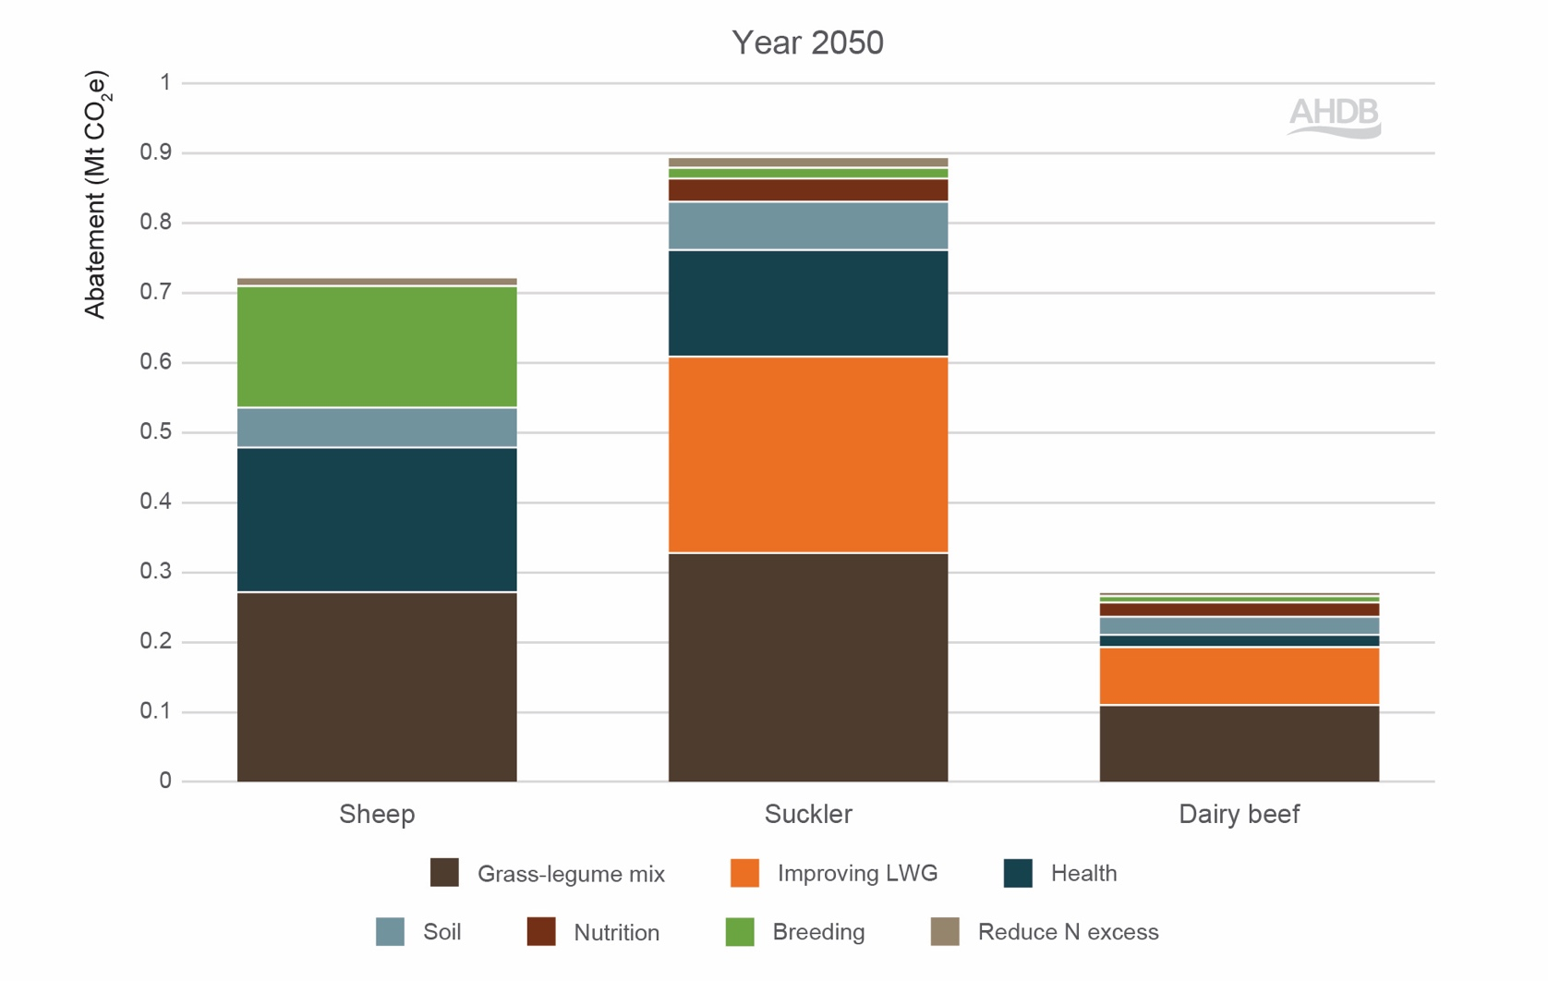
Figure 1a: Total emissions abatement potential from cost-saving mitigation measures by sector in 2050
Source: SRUC
Note: Not all mitigation measures are modelled for each sector. Refer to Table 3 to see which mitigation measures are modelled for each sector.
Note: Breeding measures are represented differently between sheep and beef systems. See interpretation box for further explanation.

Interpreting breeding abatement
Breeding measures are not directly comparable between sheep and beef systems. For beef, ongoing genetic improvement is already included within the baseline projection (‘business as usual’).
The additional breeding mitigation shown in the MACC therefore reflects only the extra gains from adopting low-emission breeding goals such as improved feed efficiency and methane-related traits. In sheep, core genetic improvement is included within the mitigation measure itself. This results in a larger visible breeding contribution in the standard MACC output. Estimated baseline genetics improvement in beef systems equates to approximately 0.281 MtCO₂e (2%) in suckler and 0.125 Mt CO2e (2.2%) in dairy beef.
Figure 1b shows the same mitigation measures as Figure 1a, but it separates the breeding contribution into baseline/core breeding improvement and additional low-emission breeding goals. This distinction is important because ongoing genetic improvement in beef is already included within the baseline projection, whereas core genetic improvement in sheep is included within the mitigation measure.

Figure 1b: Total emissions abatement potential from cost-saving mitigation measures by sector in 2050, including baseline/core breeding improvement for suckler and dairy beef
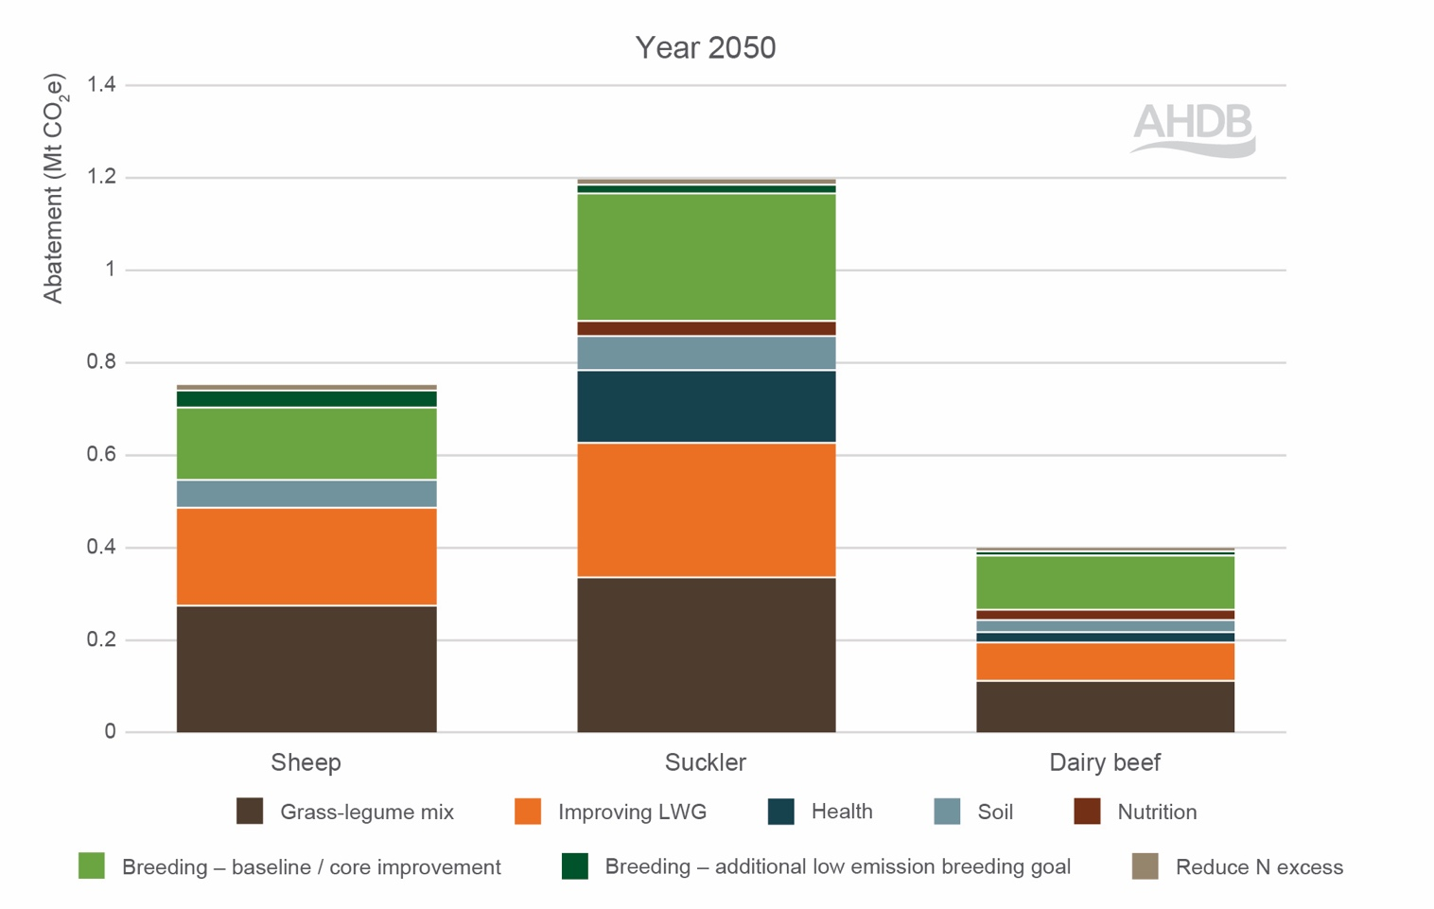

Source: SRUC

Table 4. Indicative contribution of major emission sources to baseline 2025 emissions by sector
Emission source | Sheep | Dairy beef | Suckler beef
N₂O | 14% | 15% | 15%
CO₂ | 14% | 7% | 8%
CH₄ | 72% | 78% | 76%

Table 5. Share of total 2050 mitigation by emission source Source: SRUC
Emission source | Sheep | Dairy beef | Suckler beef
Soil N₂O | 30% | 36% | 32%
Soil carbon | 4% | 4% | 4%
Energy use CO₂ | 4% | 7% | 8%
Manure management N₂O | 0% | 2% | 2%
Manure management CH₄ | 0% | 3% | 3%
Excreta on pastures N₂O | 3% | 1% | 1%
Excreta on pastures CH₄ | 1% | 0% | 0%
Enteric CH₄ | 40% | 27% | 31%
Embedded fertiliser GHG | 17% | 21% | 19%

What the MACC does not address
A MACC helps us understand what can be done, how much emissions reduction each measure could deliver and whether it saves or costs money. It supports prioritisation and sequencing of actions within the roadmap.
However, the MACC does not resolve all areas of uncertainty or debate. It does not determine methodological discussions around methane accounting, nor does it fully capture the variability and uncertainty associated with carbon sequestration. It also cannot reflect the diversity of individual farm starting points, business structure or local conditions.
The MACC is a decision support tool rather than a delivery mechanism. It identifies technical and economic potential, but real-world impact depends on adoption rates, quality of implementation, availability of robust data and coordination across the wider supply chain.

Case study
Insights from the Irish Agriculture MACC
Work led by Teagasc provides a useful comparison for the UK beef and lamb sectors. Ireland faces similar challenges around reducing agricultural GHG emissions while maintaining productive livestock systems and supporting food exports. The Irish Agriculture MACC demonstrates how substantial emissions reductions may be achievable through widespread uptake of existing measures combined with improved knowledge transfer, advisory support and policy alignment. Measures within the Irish MACC include improved nitrogen management, clover and multispecies swards, reduced age at slaughter, protected urea, low-emission slurry spreading and feed additives.
The Irish analysis suggests that full implementation of the MACC, alongside diversification measures, could achieve Ireland’s 25% reduction in agricultural emissions by 2030. The Teagasc MACC identified approximately 4.9 Mt CO2e/year of technical mitigation potential across agriculture and land use by 2030, with major contributions from methane reduction, nitrogen efficiency and land use measures.
Several individual measures highlighted in the Irish work are directly relevant to British beef and sheep systems, including:
- Reduce age at slaughter, identified as one of the largest and lowest cost methane mitigation opportunities
- Clover and multispecies swards, delivering significant reductions in fertiliser-related nitrous oxide emissions
- Protected urea, where uptake increased from approximately 1.6% of straight nitrogen fertiliser use in 2018 to 22% in 2023
- Low-emission slurry spreading (LESS) and improved nutrient management to reduce ammonia and nitrous oxide losses
Ireland has also invested heavily in implementation infrastructure through programmes such as Signpost, a joint industry–government initiative involving 120 demonstration farms, dedicated climate advisers and digital farm planning tools.
More information: Marginal Abatement Cost Curve 2023 – Teagasc |
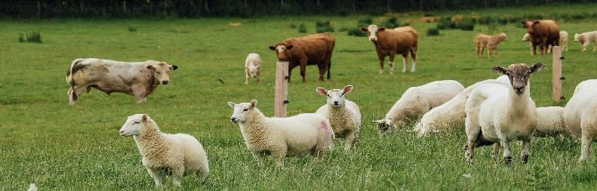

Priority cost-saving mitigation measures

This section reviews and summarises the evidence and initiatives that the sector is already championing to reduce its impact.

Optimising lifetime growth

Highlight
Definition: Reducing age at slaughter through improved health, nutrition and genetic selection to reduce lifetime emissions per animal.
Mitigation potential to 2050
Suckler beef: 296 Kt CO₂e (2.3%)
Dairy-beef: 91 Kt CO₂e (1.6%)
Primary gas reduced
Methane (via reduced lifetime enteric emissions)
Level of certainty
High biological certainty
Magnitude sensitive to production baseline and market incentives
Further work required
Reliable national finishing age data
Improved carcase data feedback
Monitoring unintended consequences

Overview
Optimising lifetime growth, particularly through earlier finishing of beef cattle, is a practical and economic mitigation measure. Cattle emit GHGs daily, with enteric methane accounting for the largest share. Reducing the number of days to slaughter lowers total lifetime emissions and reduces emissions per kilo of beef produced.
Earlier finishing also strengthens business performance. Fewer days on farm reduce feed, housing and overhead costs, improving margin alongside environmental outcomes. While progress has already been made in improving growth rates, there remains clear scope to accelerate the uptake of practices that shorten finishing periods without compromising carcase quality, animal welfare or eating quality. Optimising lifetime growth can represent a no-regrets measure if done the right way.

Evidence base and assumptions used in the MACC model
When growth rates improve, a greater proportion of feed intake is directed towards liveweight gain rather than maintenance requirements, improving biological efficiency and reducing emissions intensity.
In practice, the extent of emissions reduction depends on how increased growth rates are achieved. Age at slaughter varies considerably between systems, influenced by genetics, grazing regimes and management choices. This mitigation measure focuses on improvements in management such as optimised nutrition, improved forage quality, stronger animal health and better overall system efficiency rather than fundamental changes to production systems.
Some faster-finishing strategies may involve increased use of concentrates. However, the emissions implications of this depend on the type, quantity and sourcing of feed used. Additional concentrate feeding can increase upstream emissions, particularly where it relied on ingredients associated with higher embedded emissions or land use change, although this may be less significant where by-products or lower-impact feed materials are used. For that reason, increased concentrate use is not explicitly included within this mitigation measure, which instead focuses on improvements that can be achieved through better management of forage-based systems.
For MACC modelling purposes, it is assumed that the average age at slaughter could be reduced by approximately three months, from 22 months to 19 months (a reduction of around 13%), through improved management and performance. In the model, this is represented as an increase in growth rate, which reduces the average number of cattle required within the system over a year. This should not be interpreted as implying that 19 months is the economically optimal finishing age for all systems. In practice, the most profitable finishing point will vary between farms depending on factors such as breed, system, forage availability, input costs and market requirements. Rather, the assumption is intended to illustrate the emissions benefit that can arise where cattle reach target specification more efficiently.

Where is the sector now?

Trends in finishing age, carcase weight and carcase gain
Figures 4–6 help ground the MACC assumption in observed system performance. They show that earlier finishing is already achievable in practice and also that further progress is likely to depend on coordinated improvements across multiple areas of herd management rather than a single change in isolation. These figures show clear and consistent differences in finishing performance of beef cattle alongside a decade-long trend of improvement that has recently flattened.
Age at slaughter: Young bulls finish significantly earlier than heifers or steers. Within the data set, dairy beef heifers and steers are generally slaughtered at older ages than suckler cattle. There is an overall shift towards earlier finishing up to around 2021, including a dip in age at slaughter around that year, followed by a plateau and some recent upward movement in finishing age for suckler heifers and steers (Figure 2).
Carcase weight: Across 2015 to 2025, suckler-bred cattle consistently produce heavier carcases than dairy beef cattle, for heifers, steers and young bulls (Figure 3). Within sucklers, the expected pattern holds: young bulls are the heaviest, steers close behind and heifers are lightest. Within dairy beef, the pattern is slightly different: steers tend to be heaviest, young bulls are lighter and heifers are lightest. Over time, carcase weights are broadly stable with modest variation (for example, suckler steer weights dip around 2017 before recovering into the mid-370s kg range by 2025).
Average daily carcase gain (kg/day): When age and weight are combined into average daily carcase gain (Figure 4), the same hierarchy is clear: highest in young bulls and lowest in heifers. Suckler cattle outperform dairy beef across the period. Importantly, the decade-long improvement in carcase gain appears modest overall, reinforcing that further reductions in finishing age are most likely to come from coordinated progress across genetics, health, forage and nutrition rather than incremental change alone.
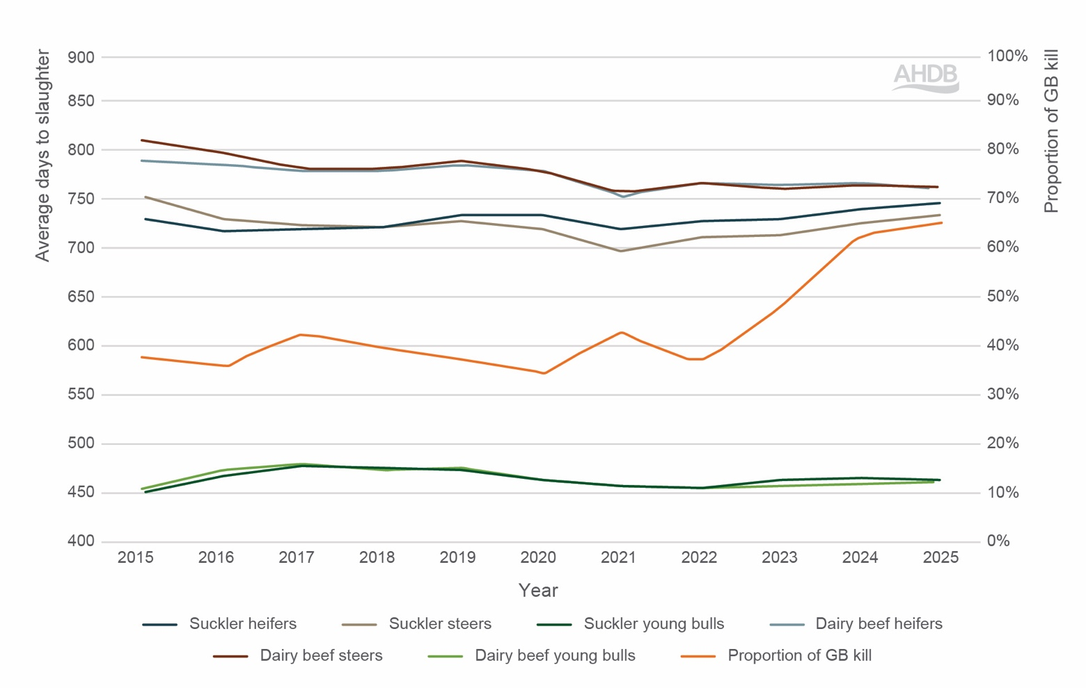
Figure 2. Average age at slaughter by type and sex from 2015 to 2025
Source: BCMS, SRUC Calculations
Note: Figures are calculated from animals included in the BCMS data set. The data set represents a proportion of total GB slaughter, and coverage may vary by year.

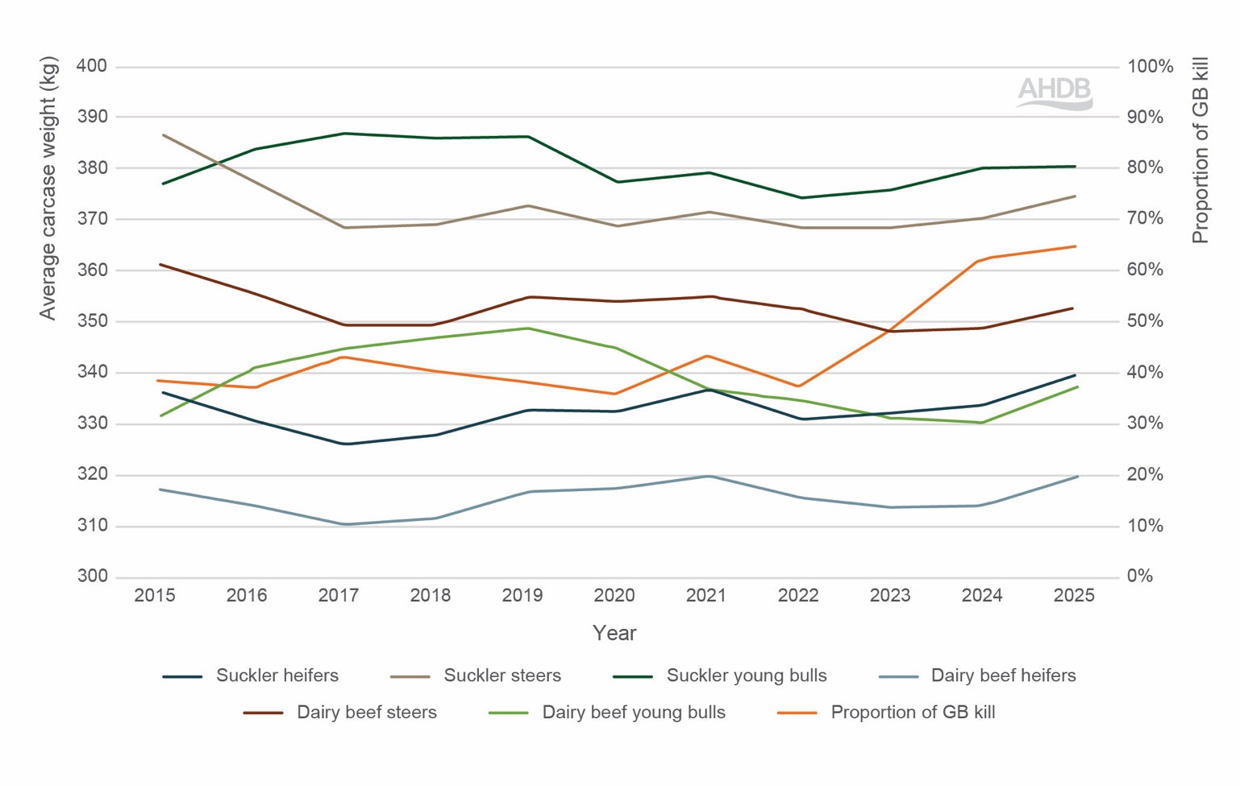
Figure 3. Average carcase weight by type and sex from 2015 to 2025
Source: BCMS, SRUC Calculations
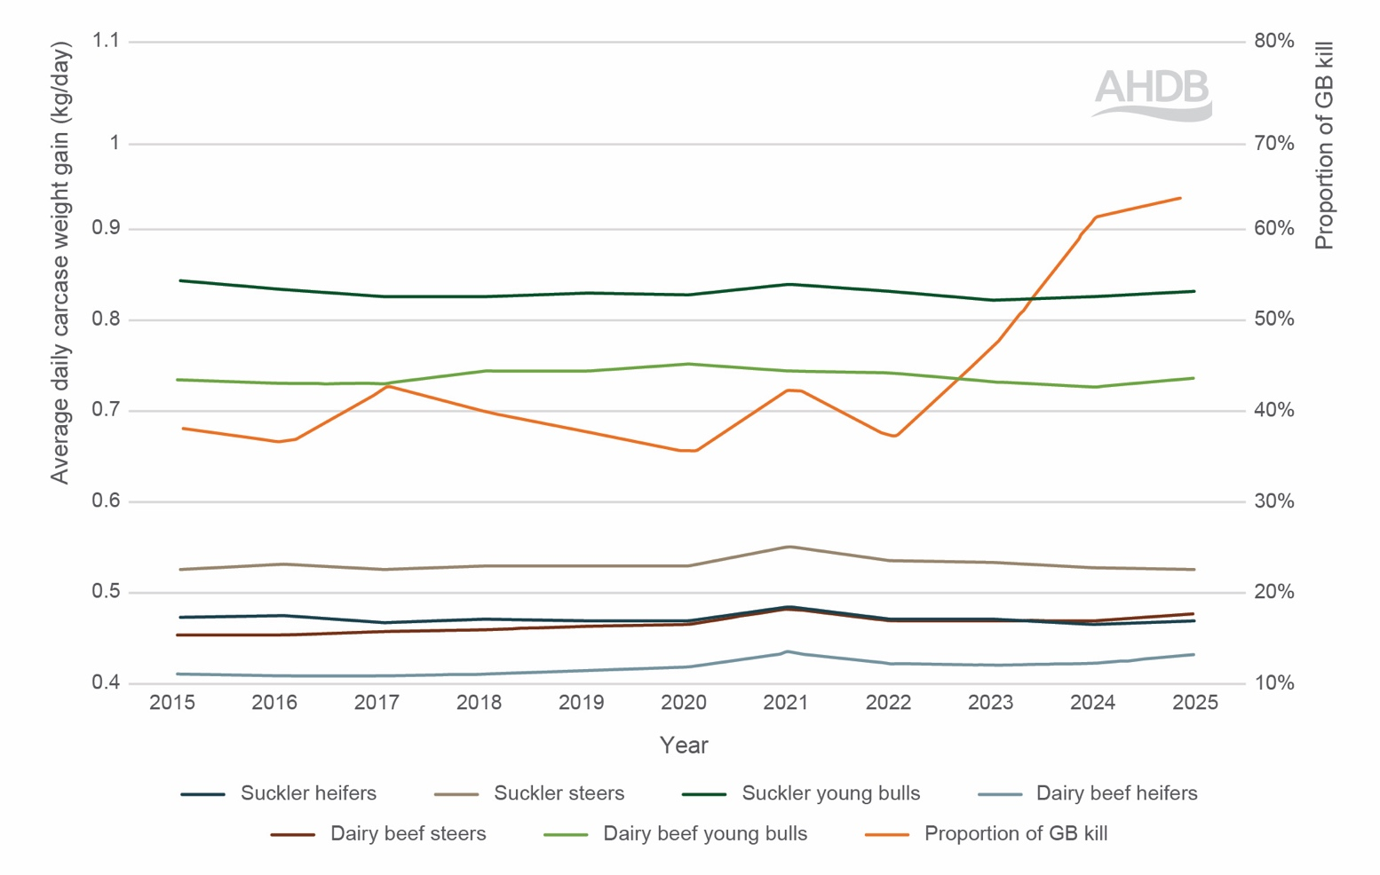
Figure 4. Average daily carcase gain (kg/day) by type and sex from 2015 to 2025
Source: BCMS, SRUC Calculations

Better growth and feed efficiency
Reducing days to slaughter is ultimately delivered by better growth and feed efficiency. Daily liveweight gain (DLWG) and feed conversion are key to lower-emission beef. However, the aim is not simply to slaughter animals earlier. It is to reach target specification more efficiently, through better growth performance over the animal’s lifetime. This is important because animals that are kept on farm longer than necessary, or that become over-fat before slaughter, add maintenance emissions and feed costs without a corresponding increase in saleable output. More efficient growth to the right slaughter endpoint is therefore the key objective, rather than earlier finishing in isolation. This aligns with wider evidence showing that improvements in productivity and efficiency can reduce GHG emissions per unit of beef produced.
In British production systems, DLWG for finishing cattle typically ranges from 0.9 to 1.4 kg/day depending on breed, nutrition and management. Research has shown that cattle gaining 1.3 kg/day can finish up to 30 days earlier than those gaining 1.0kg/day with no compromise on carcase weight or grade. This does not just save time – it reduces methane emissions by shortening the time to finishing and lowering lifetime feed demand.
Feed efficiency is crucial to sustainable finishing. A study has demonstrated that low residual feed intake (RFI) animals can consume 10–15% less feed while achieving the same daily gains. Improving feed efficiency also means reducing emissions from feed production, manure output and enteric methane. However, the emissions outcome of more extensive or later-finishing systems is more nuanced. Later finishing can increase enteric methane intensity by extending the animal’s lifetime, while lower-input forage-based systems may have lower upstream supply chain emissions. The balance between these effects depends on the specific system, feed sources and productivity achieved. Feed efficiency could reduce emission intensity by up to 20% per kg of beef produced. It also cuts feed costs, a win for both the environment and profitability.

Industry initiative
PRISM 2030
ABP’s PRISM 2030 initiative aims to improve sustainability in the British beef and lamb sector through systematic carbon footprinting and performance benchmarking. Using SRUC’s Agrecalc tool, GHG emissions were calculated for 300+ farms (excludes sequestration). The results show substantial variation between farms, ranging below 10 to over 55 kg CO₂e per kg deadweight, with the majority of farms falling between 15 and 40kg CO₂e per kg deadweight (Figures 6 and 7).
Some of this variation reflects structural differences that are not easily replicated, such as geography, soil type, system design and feed sources. However, the scale of variability also suggests significant scope for improvement through management changes alone. Where comparable systems exhibit markedly different emissions, it indicates that efficiency gains are achievable within existing production models.
This variation highlights an important point for the roadmap: reducing emissions across the sector may depend on as much on narrowing the performance gap between farms as on introducing new mitigation technologies. It also reinforces the importance of robust baseline data, benchmarking and peer learning in identifying realistic improvement opportunities.
Drawing on data from 300+ beef enterprises, the report shows that lowland suckler herds demonstrate strong growth rates of 1.10 kg/day, reaching slaughter at just over 20 months with a carcase weight of 621 kg (Table 6). Upland and hill sucklers, while slightly slower growing at 1.01 kg/day, achieve a similar
slaughter weight of 624 kg at 20.5 months of age. Beef-bred finishers stand out with the fastest daily growth (1.19 kg/day) and the heaviest slaughter weight (659 kg), though they are typically kept until 22.2 months.
By contrast, dairy-bred finishers reach the same age with a lighter carcase of 608 kg, reflecting a slower average growth rate of 1.05 kg/day. Overall, the figures underline the efficiency advantages of beef-bred systems while also recognising the valuable role of suckler and dairy-bred cattle in providing flexibility and resilience across the UK beef supply chain.
Read more here: ABP PRISM 2030Year Two Report

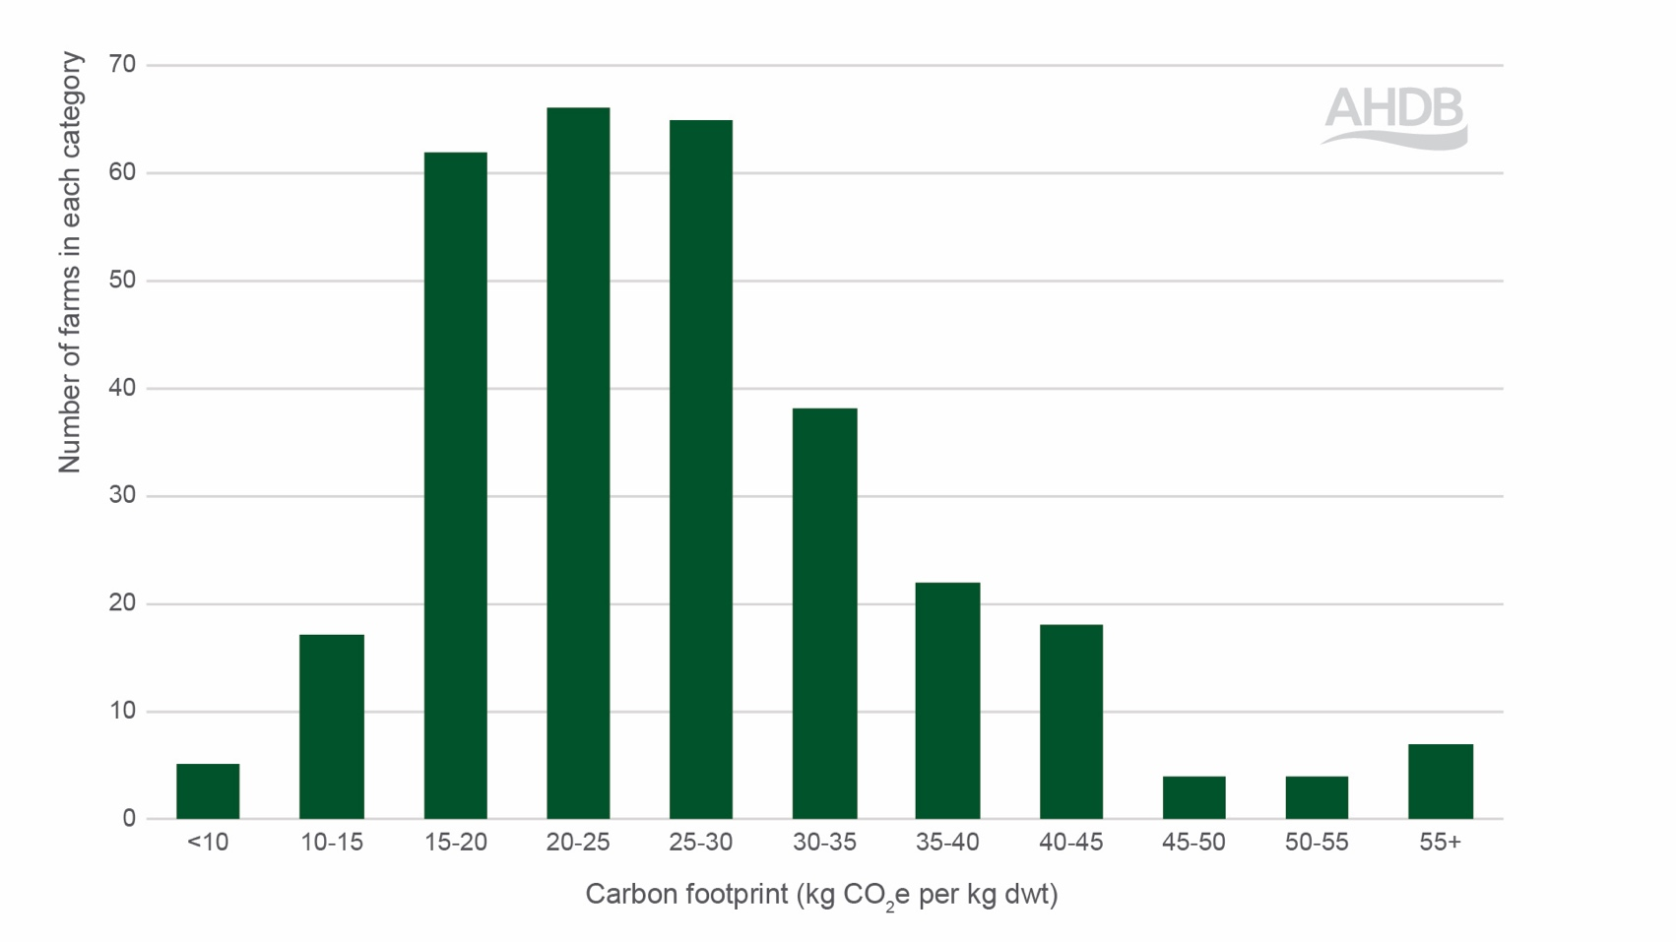
Figure 5. Range of carbon footprints (kg CO2e per kg dwt) across beef farms
Source: ABP PRISM 203014

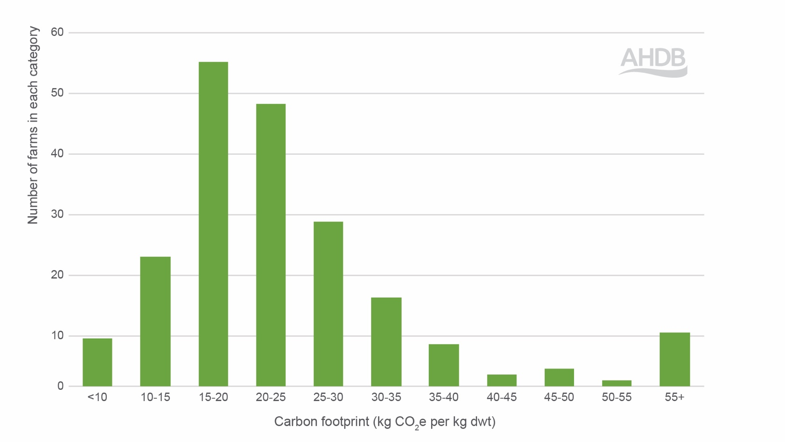
Figure 6. Range of carbon footprints (kg CO2e per kg dwt) across sheep farms
Source: ABP PRISM 203014
Table 6. Key performance indicators from the beef finishers from ABP’s PRISM initiative
Enterprise | DLWG  (kg/d) | Age at slaughter (months) | Slaughter weight (kg)
Lowland sucklers | 1.10 | 20.1 | 621
Upland and hill sucklers | 1.01 | 20.5 | 624
Beef-bred finishers | 1.19 | 22.2 | 659
Dairy-bred finishers | 1.05 | 22.2 | 608
Source: ABP PRISM 203014

Industry initiative
AHDB Environment Baselining Pilot
AHDB is running a pilot across 170 farms in England, Scotland and Wales to measure carbon in soils, hedges and trees to build a clearer environmental baseline. Included are 68 cattle and sheep enterprises.
The aims are to 1) provide the industry with accurate on-farm environmental data, reducing reliance on national and international averages, 2) demonstrate the critical role GB plays in reducing GHG, building carbon stocks, enhancing soil health and supporting biodiversity and 3) enable farmers to take insight-led action towards a more sustainable future.
Read more here: Environment Baselining Pilot | AHDB

Industry initiative
Pedigree-focused feed efficiency programmes
Across beef breeding programmes, feed efficiency is increasingly being incorporated into selection decisions. Stabiliser Cattle Company, Angus, Limousin and other breed societies have begun to incorporate feed efficiency into their breeding programmes.
Genus and Cogent offer bulls selected for feed efficiency using proprietary data. Platforms like Neogen’s “Identify Beef” genotyping pool provide predictions for residual feed intake and growth efficiency.
Read more here: Feed efficiency – Stabiliser Cattle Company

Research initiative
The Land Use for Net Zero (LUNZ) Grassland Project
The Land Use for Net Zero (LUNZ) Grassland Project is a UK wide-research initiative focused on how grasslands can support the transition to net zero while also improving soil health, biodiversity, farm productivity and rural economies.
The project recognises that grasslands cover more than 70% of the UK’s farmland and are an important natural asset, supporting food production, carbon storage, biodiversity and wider environmental outcomes.
It is exploring how improved grassland management, diverse swards, precision grazing, silvopasture, agroforestry and other land use approaches could help reduce emissions while supporting resilient farm businesses.
Read more here: Grasslands – LUNZ Hub

Measuring progress
The aim is to demonstrate how improvements in breeding, nutrition, health and management translate into both reduced days to slaughter and lower GHG emissions per kilogram of beef produced.
Key evidence and data sources will include:
- AHDB and industry data sets such as national slaughter statistics, carcase weight and average age of slaughter to track changes in finishing times over time
- Farm benchmarking data, including herd performance metrics (growth rates, feed conversion efficiency, mortality etc.) collected through farm business groups and commercial initiatives
- Genetic evaluation data from UK national genetic improvement programmes (e.g. EBVs and breeding indexes) to evidence progress in selecting faster growth and efficiency traits
- Carbon footprinting tools and baseline projects to quantify changes in emissions intensity linked to productivity gains
Tracking adoption and uptake is challenging, as there is no single, consistent data source. Many changes occur at farm level and are not routinely captured in national statistics. To overcome this, progress will be measured through a mixed-evidence approach that combines scheme participation data, surveys and industry data sets
Over time, the ambition is to develop more consistent baseline data through initiatives such as AHDB’s Environment Baselining Pilot and supply chain carbon footprinting which can offer stronger evidence of practice adoption and impact

Actions
Over the next 3–5 years, feed efficiency is expected to become a routine component of national breeding objectives, increasingly supported by genomic prediction using lower-cost DNA testing. As adoption grows, processors and supply chains are also likely to draw on efficiency signals, alongside growth and finishing performance, as part of carbon footprinting and supply chain performance reporting.
In the short term, feed efficiency will not usually appear as a standalone metric within carbon footprint outputs. Instead, its impact will be reflected indirectly through the variables carbon tools already capture well, including:
- Lower feed use per unit of output
- Improved growth performance
- Reduced age at slaughter
As data capture improves and reporting becomes more standardised, there is scope for feed efficiency
to be reported more explicitly, but this will require further alignment of measurement approaches and data sets. The sector has the tools and data to begin scaling feed efficiency measurement nationally. With collaboration, incentives and smart data use, this could become the cornerstone of sustainable,
high-performance beef production.

Nutrition

Highlight
Definition: Improving cattle diet digestibility mainly by boosting grass and silage quality and using better-balanced rations so cattle eat and grow more efficiently and produce less methane per kg of output, without increasing concentrate use.
Mitigation potential to 2050
Suckler beef: 32 Kt CO₂e (0.2%)
Dairy beef: 21 Kt CO₂e (0.4%)
Primary gas reduced
Methane (via improved feed conversion and lower methane yield per unit of intake), with secondary reductions in N₂O (better nitrogen-use efficiency, lower N excretion) and CO₂ (lower embedded emissions from feed per kg gain)
Level of certainty
High confidence in direction of effect
Moderate confidence in magnitude
Further work required
Better national data on actual diets (forage quality, concentrate inclusion, protein levels)

Overview
Nutrition plays a central role in determining both productivity and emissions in beef systems. Methane is produced as part of the rumen fermentation process that allows cattle to digest fibrous feeds such as grass and silage. The efficiency of this process is strongly influenced by diet composition and digestibility.

Evidence base and assumptions used in the MACC model
Feed quality and digestibility influence cattle productivity and the GHG emissions intensity of products too. Higher digestibility boosts dry matter intake and growth while reducing methane output per unit of feed.,
Digestibility improvements can be achieved through a range of management interventions, including:
- Improved grassland management
- High-quality silage production
- Optimised harvest timing
- Improved forage species composition (e.g. inclusion of clover)
- More precise ration formulation
Feed digestibility may also be improved through the use of more digestible ingredients or improved processing components.8 In practice, some increase in concentrate or supplement use may form part of this, and small targeted additions can sometimes deliver disproportionate gains in growth and feed efficiency relative to the extra feed used. This is particularly relevant where co-products or by-products are used, as these carry lower embedded emissions than conventional feed ingredients. However, the overall emissions effect depends on the type, quantity and sourcing of feed, and where additional concentrate use relies on higher-impact ingredients, the benefit may be partly offset. For that reason, increased concentrate inclusion was not explicitly included in this mitigation measure.
Instead, the measure assumes an improvement both in the digestibility of concentrates and in grass and silage quality, the latter through better pasture management, including fertilisation, grazing, renewal, species composition (like clover), technology and crop genetics.,
The MACC modelling assumes:
- An increase in overall ration digestibility by three percentage points. This reflects a realistic sector-wide improvement achievable through better forage quality, grassland management and ration balancing, rather than performance currently achieved only by top-performing farms
- Improved growth rates as a result of better diet quality
- Applicability across all growing cattle, although the largest relative opportunity is likely within suckler systems, where forage quality and nutritional management are typically more variable and where improvements in growth efficiency can substantially reduce lifetime methane emissions
These changes improve feed conversion efficiency and reduce methane emissions intensity by shortening the time animals spend emitting methane before reaching slaughter weight.

Where is the sector now?
Nutritional management practices vary widely across beef systems, reflecting differences in production systems, forage availability and advisory support. Many farms already implement good forage management practices, but there remains significant variation in forage quality and ration formulation. Silage quality, for example, can vary considerably depending on cutting date, conservation methods and grassland management due to factors such as the weather.
Advisory support also varies. Industry estimates suggest that approximately one-third of producers currently use professional nutritional advice when formulating rations.44
Improving forage management and nutritional planning therefore represents an opportunity to close performance gaps between farms and improve overall efficiency across the sector.
Recent research programmes are also exploring how forage composition and naturally occurring bioactive compounds may influence methane production in the rumen. While promising, these effects remain an emerging area of research and are not currently included within the MACC modelling assumptions.

Measuring progress
Progress in improving nutritional efficiency can be monitored through a combination of adoption and outcome indicators.
- Adoption indicators
- Uptake of professional nutritional advice
- Use of forage analysis and ration formulation tools
- Participation in advisory or benchmarking programmes
- Outcome indicators
- Forage digestibility metrics (e.g. D-value or ME content)
- Growth rates and daily liveweight gain
- Improved fertility
- Improved % of calves/lambs weaned
- Feed conversion efficiency
- Age at slaughter
- Tracking improvements in forage quality and growth performance will provide a practical indication of progress.

Actions
To realise the potential of improved nutrition as a mitigation measure, the following actions are recommended:
- Improve forage management
- Encourage grassland management practices that improve forage digestibility and consistency
- Promote better silage-making, grazing management and forage testing to support higher-quality diets
- Strengthen nutritional advisory support
- Increase access to professional nutritional advice
- Promote use of forage analysis and ration formulation tools
- Support farmers to make targeted nutritional improvements that improve growth and feed efficiency without undermining wider environmental performance
- Improve data on feeding practices
- Collect better data on beef diets, including forage quality, digestibility and concentrate inclusion
- Improve consistency and affordability of on-farm data collection so farmers can gather the right information efficiently
- Work with carbon tool providers to ensure nutritional data entered by farmers is used more effectively within emissions assessments, particularly where feed composition and digestibility influence enteric methane estimates
- Review where current carbon calculators are making sufficient use of available nutritional data and identify area for improvement
- Integration of nutritional data into carbon assessment tools

Animal health

Highlight
Definition: Reducing endemic disease burden through preventative health planning, vaccination, diagnostics and biosecurity to improve productivity and reduce emission intensity.
Mitigation potential to 2050
Suckler beef: 160 Kt CO₂e (1.3%)
Dairy beef: 17 Kt CO₂e (0.3%)
Sheep: 216 Kt CO₂e (3.4%)
Primary gas reduced
Methane (via improved growth rate and reduced days to slaughter), with secondary reductions in N₂O and CO2 through improved feed efficiency
Level of certainty
Moderate–high confidence (strong productivity evidence)
Disease-level quantification remains complex
Further work required
Improved disease prevalence data
Integration of health metrics into carbon tools
Better modelling of subclinical disease impacts

Overview
British beef and sheep farms are recognised worldwide for their commitment to high animal welfare and responsible livestock care. Better animal health is an effective no-regrets route to lower emissions on farm. Healthy animals grow faster, convert feed more efficiently and have fewer setbacks. Endemic diseases like BVD, Johne’s, BRD and IBR in beef cattle, lameness, parasitism and liver fluke reduce productivity and increase emissions across the whole system.

Evidence base and assumptions used in the MACC model
A substantial body of research shows that improving livestock health can reduce GHG emissions, primarily through higher growth rates, improved feed conversion, lower mortality, reduced culling, better fertility and fewer days to slaughter. The scale of impact varies by disease, severity and production system, but evidence indicates that some individual diseases can increase emissions by around 5% or more, with larger effects possible where multiple health challenges occur.,,,,,,
Quantifying the emissions impact of individual diseases using detailed modelling is complex and resource intensive, particularly because diseases interact and often occur concurrently. For this reason, the MACC adopts a top-down approach. Herds and flocks are characterised as either average or high health, and assumptions are made about the realistic potential for the national population to move from average towards high health status.

The emissions impact of endemic diseases in beef and sheep
Cattle and sheep health remains a key limiting factor in production efficiency, both in the UK and globally. Disease impacts emissions in multiple ways:
- Increased feed and forage requirements: sick animals require more feed to reach target weights, increasing methane emissions, carbon dioxide and nitrous oxide emissions from feed production, fertiliser use and transport
- Lower fertility and higher culling rates: longer calving intervals, higher replacement needs and greater mortality increase lifetime emissions per animal and mean that more animals are required to produce a given quantity of meat
- Poorer nitrogen use efficiency: diseases that impair gut function or metabolism (e.g. Johne’s disease, parasitism) lead to increase feed demand and excess nitrogen excretion in urine and manure, raising nitrous oxide and ammonia emissions
- Extended finishing periods: slower growth increases total lifetime emissions
- Higher medicine, handling and energy demand: additional treatments and housing increase indirect emissions

Evidence from cattle
Studies indicate endemic cattle disease can increase emissions intensity by between 4 and 8% or more, depending on disease and severity (Table 7).
Table 7. Impact of cattle disease on key performance indicators and greenhouse gas (GHG) emissions
Disease | Impact | Potential effect on GHGs
Bovine viral diarrhoea | Reduced fertility, increased replacements, increased mortality in calves | Moderate: 4–8%
Johne’s disease | Reduced digestion, weight loss, early culling | Moderate: 4–8%
IBR | Reduced fertility, growth rate and increased mortality | High: >8%
Lameness | Reduced feed intake, slower growth, cause of culling | Moderate: 4–8%
Bovine respiratory disease | Reduced growth rate and increased mortality in calves | Low: <4%
Liverfluke | Reduced growth rate and increased malnutrition and mortality | Low: <4%26
Source: Adapted from Capper and Williams, 2023
Bovine tuberculosis (bTB) can have substantial effects on productivity, longevity, mortality, replacement rates and herd structure, and is therefore likely to increase the GHG profile of affected beef systems. However, it is not quantified here because robust emissions estimates are not currently available.

Evidence from sheep
The evidence base for sheep is less exhaustive than for cattle, but studies and sector analyses indicate that disease, parasites and reproductive losses can have substantial impacts on both productivity and emissions intensity. Examples include:
- Foot rot: lambs affected by foot rot can lose 2–8% of liveweight, although losses can often be recovered through effective control and vaccination
- Gastrointestinal parasite burdens can increase GHG emissions from lamb production by at least 10%, with around half of the increase attributed to methane
- Foetal losses (toxoplasmosis and enzootic abortion), despite effective vaccines, reported vaccine coverage remains relatively low at 22% and 36%, respectively. The environmental implications of these diseases are substantial. Toxoplasmosis has been estimated to increase emissions intensity by approximately 4–5% per kilogram of lamb produced, while effective control of enzootic abortion could reduce emissions intensity by around 5–6%. Both diseases can largely be prevented through vaccination of ewes

The wider impact of healthy livestock
Improving animal health delivers multiple co-benefits aligned with the One Health framework, linking animal health, human health and environmental outcomes. Healthier animals typically require fewer antibiotic treatments, supporting antimicrobial stewardship and efforts to reduce antimicrobial resistance (AMR), a recognised global health threat. Improved digestion and nitrogen metabolism can also reduce nitrogen losses and associated ammonia and nitrate risks, supporting wider air and water objectives. Healthier, more resilient animals are better able to cope with climate variability (heat stress, forage disruption, extreme weather), strengthening farm resilience and food system stability.25

Where is the sector now?

Preventative parasite control
The UK industry has established two key initiatives to promote sustainable parasite control:
- Control of Worms Sustainably (COWS) promotes diagnostic-led worm control in cattle
- Sustainable Control of Parasites in Sheep (SCOPS) promotes integrated parasite management in sheep, including use of faecal egg counts and quarantine protocols, to reduce reliance on blanket treatments and slow the development of resistance
These initiatives support targeted treatment, resistance management and improved animal performance, reducing emissions intensity through improved growth efficiency.

Responsible medicine use
The UK livestock sector has made significant progress on antimicrobial stewardship through coordinated industry action, improved data collection and strong veterinary engagement. Key initiatives include:
- The Responsible Use of Medicines in Agriculture (RUMA) Alliance provides a strong example of cross-sector collaboration, with industry stakeholders setting and delivering antimicrobial use (AMU) reduction targets proactively, ahead of regulatory requirements
- Medicine Hub, developed by AHDB, offers a centralised digital platform for the collection and reporting of antibiotic usage data from UK cattle and sheep farms. Anonymous, aggregated reporting improves transparency, supports responsible medicine use and strengthens the sector’s evidence base for policy, assurance and retailer engagement. Continued expansion of participation and data completeness will be important to improve representativeness and support robust long-term sector analysis
- Arwain DGC in Wales promotes responsible antimicrobial use in beef and sheep systems through farmer engagement, veterinary leadership and improved diagnostics, reducing unnecessary treatments and supporting long-term system sustainability
- The UK has achieved a 57% reduction in antibiotic sales for livestock over the last decade and is now recognised as one of the lower users of on-farm antimicrobials in Europe, reflecting substantial progress made by the livestock sector over recent years. This progress demonstrates the value of coordinated industry action, voluntary reporting and continued veterinary engagement
- Responsible medicine use is closely linked to improved herd and flock health. Healthier animals are generally more productive and efficient, which in turn support lower GHG emissions intensity through improved growth, fertility and feed conversion efficiency

Vaccine uptake
National vaccine uptake reporting (based on wholesaler sales data) provides insight into preventative health capacity. Cattle vaccine doses sold rose 24% between 2011 and 2024, with IBR vaccination increasing by 88%, though BVD vaccination fell by 18%. Sheep vaccine uptake declined in 2024 due to a sharp decline in enzootic abortion vaccine availability in 2024. The uptake for foot rot vaccines rose by 53% between 2012 and 2024. The estimated uptake for toxoplasmosis vaccination also rose by 2%. Stable and secure vaccine supply remains critical for consistent disease control.

Herd and flock health planning
Structured herd and flock health planning is increasingly embedded within assurance and government support frameworks in both England and Wales.
In England, over 80% of finished beef and 50% of finished lambs are Red Tractor assured. Beef and lamb farms certified under Red Tractor Assurance maintain a written health plan and complete an annual health and performance review with a vet.
Through the Animal Health and Welfare Pathway, farmers in England can access funding for veterinary visits to assess livestock health and welfare. These visits include testing for endemic diseases and tailored advice on improving health, productivity and biosecurity. Follow-up funding is available to support more detailed diagnostics and the implementation of disease control and prevention measures. Policy developments in this area are ongoing, including consideration of how participation in some elements of the pathway may evolve over time.
In Wales, the Farm Assured Welsh Livestock (FAWL) Beef and Lamb Scheme operates as the primary assurance scheme for cattle and sheep. Approximately 70% of the breeding livestock population in Wales is covered under FAWL, which requires an annual health and welfare review with a farm vet.
From January 2026, the Welsh Government’s Sustainable Farming Scheme will introduce the Animal Health Improvement Cycle (AHIC). This framework is designed to support structure, preventive health planning through an annual cycle of measuring key health and production metrics, agreeing improvement plans with veterinary input, implementing actions and reviewing outcomes.

Other health and welfare industry initiatives
- Cattle Health Certification Standards (CHeCS) is an industry-owned body that sets, regulates and quality controls health schemes across the UK. It has developed a set of standards for the control or elimination of key infectious cattle diseases, including BVD, IBR, Johne’s disease, TB, leptospirosis and Neospora
- The Bovine Viral Diarrhoea (BVD) Free England (2016–2024) registered 6,972 holdings, representing approximately 45% of all beef and dairy breeding cattle in England. Although the scheme has now closed, BVD control remains a priority. The CHeCS framework continues to support BVD management through four licensed health schemes and the Animal Health and Welfare Pathway provides funding for annual vet visits, including BVD testing
- In Wales, Gwaredu BVD (Eradicating BVD) screened 85% of cattle farms between 2017 and 2022. Eradicating BVD from a typical Welsh herd of 40 cattle could reduce the carbon footprint by around 70,200 kg CO2 annually. In summer 2024, the Welsh Government introduced legislation to support full eradication
- The UK Sheep Welfare Strategy, led by the Ruminant Health and Welfare Group (RHW), sets out six strategic goals to drive improvements in sheep health and welfare
- The UK Beef Welfare Strategy, led by the Ruminant Health and Welfare Group (RHW), sets out a vision for beef cattle welfare in the UK by 2031, with a focus on improving six strategic goals

Case Study
Targeted worm dosing sees lamb producer slash drench use
A Welsh sheep farmer trialled a targeted selective treatment (TST) approach to parasite control, using individual indicators such as faecal egg counts and growth rates to determine which lambs actually needed worming rather than dosing the whole group.
Over two treatment cycles, this strategy cut anthelmintic doses by more than half and saved hundreds of treatments and around £60 in drench costs, compared with blanket dosing.
Read more here: Targeted worm dosing sees lamb producer slash drench use | Farming Connect

Measuring progress
Tracking success requires clear, practical metrics that reflect both animal outcomes and the environmental impact of healthier cattle and sheep. Fortunately, the building blocks are already in place and more are coming. To demonstrate real progress on farm across the sector, changes can be tracked in medicine use, vaccine uptake and herd and flock health planning.
Measuring progress is not just about ticking boxes; it is about giving farmers and the wider industry confidence that what they are doing is delivering results. By using smarter, joined-up metrics, the sector can track progress, highlight best practice and ensure that better cattle and sheep health continues to drive environmental outcomes.

Actions
To unlock the mitigation potential of improved health, coordinated action is needed across the sector,
which should:
- Increase uptake of structure preventative health planning
- Improve integration of health, productivity and carbon data
- Focus action on high-impact endemic conditions
- Strengthen vaccine supply resilience
- Expand training and peer learning through veterinary networks and Sustainable Farming Networks

Genetics and breeding

Highlight
Definition: Selection of traits that improve biological efficiency (e.g. growth rate, feed efficiency, fertility, age at first calving, mature weight and methane intensity) using EBVs, genomic tools and environmental indexes.
Mitigation potential to 2050
Suckler beef 13 Kt CO₂e (0.1%)
Dairy beef: 6 Kt CO₂e (0.1%)
Sheep 177 Kt CO₂e (2.8%)
Primary gas reduced
Methane via improved feed efficiency and reduced lifetime emissions with secondary reductions linked to improved fertility and lower replacement rates
Level of certainty
High confidence in direction of effect
Moderate confidence in magnitude (dependent on adoption)
Further work required
Integration of methane EBVs and environmental breeding indexes
Improved update data (especially suckler systems)
Better linkage between breeding data and carbon tools

Overview
By selecting animals that grow faster, convert feed more efficiently and show stronger resilience to disease, the sector can improve productivity while cutting emissions. Importantly, this will also have positive impacts on health and profitability, making it a particularly attractive mitigation measure.
Better genetics can be adopted across the wide diversity of farms seen in beef farming. It does not require a change of system or even breed. All farms, even those who do not directly select for these breeding goals, or do not use AI, will likely experience a ‘cascade effect’ through purchased breeding bulls and/or replacement females. Tools like Estimated Breeding Values (EBVs) and, more recently, genomic testing (to produce Genomic Breeding Values) can support more informed breeding decisions, helping to accelerate the performance improvements needed to reduce emissions intensity through better outcomes on the ground. As with any abatement strategy, the contribution genetics can make depends on both the effectiveness of the traits selected and the level of adoption across the sector. Importantly, genetic potential is only fully realised when it is matched with appropriate systems and management.

Evidence base and assumptions used in the MACC model

Wider uptake of breeding tools and selection for additional traits (sheep)
In sheep systems, genetic improvement influences both absolute emissions and emissions intensity. The MACC assumes genetic progress is delivered through performance recording in breeding flocks and the subsequent purchase of superior replacement rams by commercial flocks. In principle, this approach is applicable across the national flock, assuming breeding flocks can expand to meet demand. Two distinct mitigation measures are modelled:
- Uptake of high-EBV rams for core traits: This measure assumes commercial flocks purchase replacement rams with high EBVs for core production traits, such as lamb growth rate. Emissions intensity across the flock is assumed to fall by 5% over 20 years, with an adoption of 80%.
- Selection for additional and non-core traits: This measure builds on core trait selection by including additional traits linked to efficiency and resilience, such as lamb survival, residual feed intake and enteric methane yield. Under this scenario, emissions intensity is assumed to fall by a further 4% over 20 years, with an adoption of 90%.
Together, these measures highlight the cumulative nature of genetic improvement in sheep systems and the importance of both wider uptake and broader trait selection to accelerate emissions reductions. These assumptions represent a feasible long-term pathway at sector level, but practical constraints remain. Uptake may be influenced by the availability of high-EBV rams, the cost of recorded breeding stock, variable participation in performance recording and limited data availability within some smaller or more extensive flocks. Continued expansion of recording infrastructure, breeder engagement and access to performance data will therefore be important to support wider adoption across the sector.

Lower-emissions breeding goals (suckler beef and dairy beef)
Genetic improvement has long been a feature of livestock production and has delivered substantial gains in productivity across species. In beef systems, genetic change influences GHG emissions not only through growth and efficiency but also through herd structure, animal robustness and biological processes such as rumen methanogenesis.
Historic improvements in beef emissions intensity under GWP100-based accounting are assumed within the MACC baseline to continue under existing breeding objectives and management practices. These underlying improvements reflect long-term cumulative gains in productivity, feed efficiency and animal performance that have historically occurred through ongoing genetic progress and wider system improvement.
The breeding mitigation measure therefore presents additional improvement beyond this ‘business as usual’ trajectory. This is achieved by incorporating emissions-related traits directly into breeding goals, including traits linked to feed conversion efficiency and enteric methane intensity, for example through environmental breeding indexes such as the EnviroBeef Index.

Where is the sector now?
Economic breeding goals designed to enhance traits like growth rate, fertility, survivability, age at first calving and mature cow weight can reduce carbon footprints by improving the overall input–output balance of herds and flocks. Fewer days on farm, lower lifetime feed inputs and more consistent performance all translate into lower emissions per kilogram of output.
Genetics can go a step further by integrating economically important traits into an environmental indexes, allowing animals to be ranked on their overall carbon efficiency alongside productivity and profitability. By selecting animals using these indexes, producers can gradually shift their herd or flock towards lower-emission systems over time.

Sheep
Sheep breeders already have access to well-established genetic and genomic evaluations tools. Performance recording is embedded across many flocks using services delivered by AHDB Signet Breeding Services and Innovis. Around 25% of terminal sire rams sold are performance recorded, with uptake rising in maternal breeds. More than 50 EBVs are available, covering traits linked directly or indirectly to emissions, including growth rate, lamb survival, longevity, mature ewe weight and worm resistance.
Long-term genetic progress is clearly evident. Lambs born today significantly outperform previous generations for key production traits, demonstrating the cumulative impact of selection even in systems without widespread artificial insemination. For example, Charollais lambs born in 1990 that ranked in the top 10% for terminal index values would sit within the lowest 5% of lambs born in 2017. Existing breeding programmes include:
- Terminal Sire Evaluation, focused on slaughter lamb production
- Maternal breeding evaluates both slaughter lamb and female replacements
- Hill Sheep Breeding Evaluation, designed for extensive, multi-purpose hill systems
New environmental indexes are also being developed. These include methane-related traits, feed efficiency indicators and measures linked to survival and days to slaughter.
Balanced breeding remains important. Experience in breeds such as Lleyn shows that selection for faster growth has successfully reduced days to slaughter and lifted lambs reared per ewe, lowering emissions per kilogram of meat. However, this progress has been partially offset by an increase in mature ewe weight, which raises maintenance emissions.
To further accelerate progress, two new Enviro-Indices are in development. Terminal Sire Enviro-Index harnesses traits such as days to slaughter and lamb survival. Research is looking at indirect methane indicators (specifically CT-scanned rumen volume to identify lower emission sires). Maternal Enviro-Index focuses on replacements with strong maternal traits, combining direct methane measures with indirect indicators such as lamb survival and prolificacy EBVs.

Beef cattle
Beef breeding has made progress, but the pace of improvement has been slower than in sheep, largely due to historically fragmented evaluation systems. Genetic evaluations have tended to sit within individual breed societies or breeding companies, limiting the ability to track performance consistently across the wider commercial population.
The introduction of National Beef Evaluations (NBE) in 2018 represented a significant step forward. NBE combines BCMS data with more than 14 million abattoir records to produce UK-wide, multi-breed evaluations across both pure-bred and cross-bred cattle. Recorded traits include days to slaughter and age at first calving, which are directly linked to both emissions intensity and farm profitability. Despite this progress, the adoption of NBE-informed breeding decisions remains relatively limited.
The launch of the EnviroBeef Index in August 2025 represents a further step change.3 This index provides a practical tool to help producers identify and select animals with the genetic potential to reduce emissions in suckler beef systems while maintaining productivity. It brings together traits associated with lower emissions, such as age at first calving and mature cow weight, alongside productivity and efficiency traits, including carcase weight, EUROP grade, fertility and survival. Evidence shows that genetic improvement has already delivered around a 0.1% annual reduction in herd-level emissions, equating to a 1.7% reduction between 2003 and 2018. The scope to accelerate this progress is substantial. Case study shows substantial variation in carbon footprint breeding values, ranging from approximately +6% to −14%, highlighting the opportunity to reduce emissions through breeding decisions alone, without requiring fundamental changes to production systems. As in sheep, genetic gains are cumulative, with each generation building on the last.
The principal constraint on further progress is uptake. The EnviroBeef Index has been designed to support improvement across three linked outcomes: profitability, reduced carbon intensity and enhanced animal welfare. Scenario analysis suggests that increasing adoption of the index could deliver meaningful emissions reductions over the coming years, alongside measurable business benefits.

Evidence of potential gains and adoption
Evidence of the gains achievable through genetic improvement is already clear across both beef and sheep systems (Table 8).
In beef, historic genetic progress is estimated to be worth an estimated £6.8 million annually, with a net present value of £84 million over 20 years. From an environmental perspective, this equates to a saving of around 5,000 tonnes of CO₂e per year, equivalent to around 0.08% cut in gross emissions. At farm level, a suckler calf born in 2021 now has the genetic potential to finish 14 days earlier than one born in 2001, saving 2.04 kg CO₂e per animal. Dairy beef calves are improving even faster, finishing 24 days earlier and saving 3.64 kg CO₂e per head, driven by more consistent breeding goals and stronger data integration.
Market signals have reinforced this trend. Supply chain specifications that place greater emphasis on age at slaughter and consistency have encouraged farmers to improve efficiency, supported by genetics that deliver faster finishing and more consistent performance. In 2025, 42% of holdings used bulls with high EBVs at least some of the time when breeding beef cattle.6
In sheep, genetic progress is even more advanced. Annual benefits are estimated at £14.7 million, alongside an average 0.23% annual reduction in emissions intensity, equivalent to 0.03 kg CO₂e per kilo of product. Evidence from RamCompare shows that high EBV rams produce lambs that finish sooner, grade better and return an extra £4–£6 per lamb. Around 15–20% of the national flock records EBVs when selecting rams for terminal sire traits, and in 2025, over a third (35%) of holdings used rams with a high EBVs at least some of the time when breeding lambs.
Table 8. Key indicators of genetics and breeding progress
Indicator | Beef | Sheep
Estimated annual value of historic genetic improvement | £6.8m/year | £14.7m/year
Estimated emissions impact | ~5,000 t CO₂e/year | 0.23% annual reduction in emissions intensity
Performance gain | Suckler calves finish 14 days earlier than 2001-born animals | High-EBV rams improve finishing speed and carcase performance
Additional farm-level benefit | Dairy beef calves finish 24 days earlier | RamCompare shows £2–£5/head improvement
Indicative uptake | 42% of holdings use high-EBV beef bulls at least some of the time | 35% of holdings use high-EBV rams at least some of the time
Recording participation | Variable, especially in suckler systems | 15–20% of flock records EBVs when selecting rams for terminal sire traits

The principal constraint on further progress is now less about the underlying biology and more about the rate of adoption of performance recording, environmental indexes and data-driven breeding decisions across the wider commercial sector.
Table 9. Indicative uptake and future opportunity for breeding tools and environmental indexes
Area | Current position | Future opportunity | Potential emission impact
Performance recording (sheep) | Established across many pedigree and recorded flocks | Wider uptake across commercial flocks | Improved growth, survival and efficiency
High EBV ram uptake | Increasing but variable | Greater use of high-index rams across commercial systems | Reduced emissions intensity through cumulative genetic gain
Methane-related traits (sheep) | Emerging research and limited commercial use | Integration into mainstream indexes | Additional reduction in enteric methane
Performance recording (beef) | Established in some pedigree and dairy beef systems; more variable in suckler herds | Wider participation and stronger data flows | Improved feed efficiency and productivity
Environmental breeding indexes (e.g. EnviroBeef) | Early stage adoption | Wider integration into breeding decisions | Additional reductions beyond business-as-usual genetic progress
Genomic and environmental data integration | Developing | Improved linkage between breeding, carcase and carbon data | Better targeting and measurement of emissions reduction

Latest research Breeding for lower methane
Breeding for lower methane
The next frontier in livestock genetics is the direct reduction of methane emissions without compromising productivity. Research programmes are now generating the data needed to integrate methane traits into national genetic evaluations.
In sheep, Breed for CH4nge, led by Innovis and funded by Defra, is developing a genomic reference population to embed methane measures directly into breeding indexes. Data from thousands of sheep across multiple maternal breeds show 40–50% variation in methane output within breeds, indicating substantial scope for selection. In some cases, daughters of top-performing rams achieve the same carcase weight on less feed, delivering markedly lower methane intensity.
In beef, the international BLUEGRASS project, supported by the Global Methane Hub, is linking direct methane measurements with feed efficiency and productivity traits to develop EBVs and GEBVs for methane emissions. These efforts mean beef farmers may soon be able to select cattle not only for growth, fertility and carcase traits but also on their potential to reduce methane emissions.
Several other initiatives are helping to embed breeding as a climate solution:
- Beef Feed Efficiency Programme: Delivering genomic breeding values (GEBVs) for feed intake. In 2024, this programme started to generate GEBVs for all genotyped Limousins.
- GB Calf Strategy 2025–2030: A cross-sector initiative aimed at improving the consistency, performance and value of calves entering the beef supply chain. By strengthening breeding decisions and alignment across dairy beef systems, the strategy supports gains in growth, efficiency and emissions intensity.
- RamCompare: Industry-leading project linking EBVs with carcase data; results highlight both economic and environmental benefits.⁴⁵
- Welsh Sheep Genetics Programme: Ninety-five flocks are participating in the Welsh Sheep Genetics Programme delivered by Farming Connect with support from Innovis and AHDB–Signet. This support package offers sheep farmers technical and financial support, guidance and advice to strengthen their flock’s performance, improve productivity and increase profitability through improving genetics.

Case Study
Feeding and breeding key to lower emissions
RAFT solutions have been working with Morrisons and one of its Blueprint Beef farmers, Tim Phipps, on a project supported by Innovate UK aimed at reducing the carbon footprint of the beef supplied to the retailer.
The initiative explores how targeted breeding practices, specifically the use of sexed semen, can enhance sustainability in the beef herd by improving genetic progress and efficiency. These innovations are designed to help produce beef with a lower environmental impact through smarter breeding and production practices.
Read more here: Feeding and breeding key to lower emissions

Measuring progress
Progress can be measured via genetic trends (days to slaughter, carcase weight), uptake of environmental indexes (EnviroBeef) and reported EBV usage in national surveys. Modelling and observed trends indicate that annual emissions-intensity reductions of 0.1–0.23% are achievable and already under way. While modest on an annual basis, cumulative improvements of this scale equate to approximately 1–2.3% reductions over a decade, before accounting for any additional gains from targeted low-emission breeding goals or wider adoption of environmental indexes.
The sector’s ambition is:
- By 2030, widespread availability and use of environmental breeding indexes
- By the mid-2030s, methane EBVs integrated into routine selection
- By 2050, breeding for efficiency, resilience and low emissions becomes business as usual. This is not just theoretical; it’s grounded in data and already under way
- To deliver this, the sector must close the loop between genetic improvement, measurement and impact, supported by integrated data, farmer-friendly tools, aligned supply chain incentives and a clear, consistent national message that demonstrates the practical and financial value of breeding for a lower-carbon future

Actions
To unlock the full potential of genetic improvement, the sector must close the loop between genetic improvement, measurement and impact by:
- Building on national existing evaluations by integrating pedigree, commercial, genomic and carcase data to track impact across the supply chain
- Prioritising traits aligned with environmental goals, especially feed efficiency and methane alongside maintaining productivity
- Embedding genetics within carbon accounting, collaborate with carbon tool providers to embed EBV informed carbon metrics
- Rolling out environmental indexes across all major beef and sheep breeds
- Developing targeted incentive schemes to support use of high-EBV sires and rams
- Improve understanding of EBV value; move beyond awareness to confidence in outcomes
- Accelerating uptake within suckler systems, where adoption of structured breeding tools and environmental indexes remain more variable and where significant opportunity exists to improve efficiency and reduce emissions
- Aligning breeding with evolving supply chains, recognise the role of dairy beef in UK beef supply and the importance of genetics in delivering processing consistency and lower emissions
- Developing a unified national message; promote stories showing how EBVs and indices have cut finishing time, improved lambing or reduced feed costs alongside environmental gains
- Expanding targeted training and knowledge exchange and demonstration activity to improve uptake across the wider commercial sector

Soil health (pH, compaction and drainage)

Highlight
Definition: Correcting soil acidity, relieving compaction and improving drainage to increase forage yield, nitrogen efficiency and reduce N2O emissions.
Mitigation potential to 2050
Suckler beef: 69 Kt CO₂e (0.5%)
Dairy beef: 23 Kt CO₂e (0.4%)
Sheep: 56 Kt CO₂e (0.9%)
Primary gas reduced
Nitrous oxide (N₂O)
Level of certainty
High confidence in productivity response
Moderate confidence in emissions quantification (soil variability)
Further work required
Improved national drainage condition data
Standardised soil health metrics
Monitoring lime application trends

Overview
Soil health underpins sustainable beef and lamb production. Healthy soils support pasture productivity, biodiversity, water regulation and carbon storage. In livestock systems, soil condition directly influences forage yield, nitrogen efficiency, resilience to drought and flooding, and ultimately emissions intensity.
Addressing constraints such as compaction, suboptimal pH and poor drainage can deliver important productivity emissions benefits. These measures primarily reduce emissions through improved nitrogen use efficiency, lower nitrous oxide emissions and better forage productivity.
Improved soil management may help maintain or increase soil carbon stocks over time, creating additional climate benefits beyond those directly quantified within the MACC. However, these wider sequestration benefits remain difficult to quantify consistently at sector level because outcomes depend heavily on soil type, climate, baseline carbon status, management history and weather conditions.
The MACC therefore focuses primarily on the more directly quantifiable effects of improved soil function, particularly reductions in N2O emissions and improvement in productivity. Potential benefits linked to soil carbon storage, biodiversity, water retention and wider ecosystem resilience are likely to be important, but they are not fully captured within the modelled mitigation values presented here.

Livestock as part of the soil solution
It is important to recognise that well-managed beef and sheep systems can positively contribute to soil function through:
- Recycling of farmyard manure and slurry
- Use of diverse and multispecies swards
- Inclusion of deeper rooting species
- Clover and legumes to support nitrogen cycling
- Appropriate grazing management
- When grazing pressure aligns with soil conditions and rest periods are managed appropriately, livestock can enhance soil structure, water infiltration and organic matter inputs. These interactions create the potential for multiple environmental benefits across productivity, resilience, biodiversity and carbon management

Evidence base and assumptions used in the MACC model

Reducing soil compaction (suckler beef, dairy beef, sheep)
Compaction restricts root growth, reduces infiltration and increases denitrification risk. Compacted soils emit 1.2–7.4 times more N₂O in grasslands and 1.4–9.9 times more in croplands than non-compacted soils. Compaction also reduces yields, increasing emissions intensity.
MACC assumptions:
- Direct N₂O emissions decrease by 10% (excluding permanent grass)
- Non-grass crop yield increases by 2%
- Temporary grass yield increases by 1%

Improving soil pH (suckler beef, dairy beef, sheep)
Most forage crops perform optimally at pH 5.5–6.5. Acidic soils restrict nutrient availability, depress yield and increase N₂O emissions. Evidence indicates that each one-unit increase in soil pH reduces the IPCC default N₂O emission factor by approximately 0.38%. Grass yields may fall by 30–40% if pH declines from 6.5 to 5.5.
MACC assumptions:
- Direct N₂O emissions decrease by 19%
- Crop yield increases by 6%
- Suboptimal pH estimated on 9% of arable and 22% of grassland

Improving drainage on mineral soils (suckler beef, dairy beef, sheep)
Waterlogged soils increase N₂O emissions and restrict root function. Drainage renewal improves accessibility, yield and nitrogen efficiency.
MACC assumptions:
- Direct N₂O decreases by 64% on waterlogged soils
- Crop yield increases by 11%
- Drainage issues estimated on 8% of cropland and 10% of grassland
It is important to note that the MACC captures the direct benefit of improved soil function primarily through lower N₂O emissions, better nitrogen use efficiency and improved productivity. It does not fully capture potential wider co-benefits such as increased soil carbon storage because these are harder to quantify consistently and depend on site-specific factors, including soil type, baseline carbon status, climate and management history.

Where is the sector now?

Soil monitoring
Monitoring of soil organic matter (SOM) is improving. In 2025, 59% of farmers reported tracking SOM, up from 53% in 2024. While this reflects positive movement, it also indicates that around 40% of farms are not yet routinely monitoring a core soil health metric. Specific uptake data for beef and sheep enterprises is limited.
There is also growing recognition that livestock soils may hold substantial carbon stocks, but the scale, distribution and future sequestration potential remain incompletely understood at sector level. AHDB’s Environment Baselining Pilot is beginning to address this evidence gap by measuring carbon stocks above and below ground, including soils, trees and hedges, across 170 farms in Great Britain. This work is intended to strengthen understanding of existing farm carbon stocks and improve the evidence base for assessing change over time.

Soil pH
Suboptimal soil pH remains a widespread constraint on productivity and emissions performance:
- 57% of grassland soils have a pH below 6.0
- Fewer than half of Welsh grassland soils are within the recommended ranges
- 98% of grassland soils in a survey of 302 beef and sheep farms failed to meet recommended thresholds for at least one of four key indicators (pH, P, K, Mg)
- Only 51% of English beef and lamb producers report regular soil index testing
- Only 6.2% of fields received lime in 2024
- Agriculture limestone use has halved since the 1980s36
- For Wales, it is also important to recognise that the practical scope for pH correction and wider soil intervention may vary with land capability, topography, habitat constraints and the prevalence of SDA/LFA land. This reinforces the need for realistic assumptions about uptake and suitability across different systems

Drainage
Many field drainage systems pre-date the 1990s and have received limited maintenance. Robust national data on drainage condition are limited, but underperforming drainage is widely associated with yield loss, compaction risk and increased emissions. Overall, progress is evident in soil monitoring, but it highlights substantial scope for improvement in pH correction, compaction management and drainage renewal across beef and sheep systems.

Policy and industry context
In 1992, there were 0.3 million hectares of land in the UK in higher-level agreements or targeted schemes, and by 2022, the total land in higher-level or targeted agri-environment agreements in the UK has risen to just under 3.7 million hectares. In 2022, farms with higher-level or targeted agri-environment agreements accounted for 26% of area on agricultural holdings in England, 22% in Wales and 17% in Scotland. The United Kingdom was one of the first countries in the EU to introduce agri-environment schemes. Approximately 77,000 live agri-environment agreements are currently in place in England. Soil management standards are the most widely adopted option within SFI, reflecting the central role of soil in delivering environmental outcomes.
Defra has committed to an ambitious goal for 40% of agricultural soils in England to be under sustainable management by 2028, rising to 60% by 2030. Unlike England, Welsh Government does not set specific percentage targets for agricultural soils under sustainable management. Specific strategies to manage agricultural soils are primarily delivered through the SFS which launched in 2026. The Office for Environmental Protection (OEP) has identified over 50 soil and land management measures that support sustainable soil management.
National monitoring initiatives include:
- UK Centre for Ecology and Hydrology’s (UKCEH) Countryside Survey
- Environment and Rural Affairs Monitoring and Modelling Programme (ERAMMP) in Wales
- England Ecosystem Survey – part of the natural capital and ecosystem assessment programme
- SFS in Wales (UA1 Soil Health)

Industry initiative
Catchment Sensitive Farming
Catchment Sensitive Farming is a UK programme (specifically in England) run by Natural England and Defra that works with farmers in priority catchments to reduce pollution (nutrients, sediment), improve soil management and mitigate diffuse water pollution. It offers advice, training and sometimes grant support in areas including soil structure, slurry and manure handling, erosion control and nutrient management.
Though not livestock-only, many beef and sheep farms benefit in catchment zones. CSF offers grants and guidance on drainage and liming.
Read more here: Catchment Sensitive Farming

Industry initiative
UK Soil Health Initiative (UK SHI)
A cross-industry partnership (including WWF–Tesco, ADAS, AHDB, NFU, CFE, universities) that developed a series of practical soil health guides tailored to different farm types, including lowland livestock farms and upland livestock farms.
Read more here: UK Soil Health Initiative

Industry initiative
AIC engagement in soil-health advocacy
AIC (representing the fertiliser and agri-supply industry) has engaged in initiatives like Championing the Farmed Environment, Catchment Sensitive Farming and partnership work on GHG action. Its role is more in policy, coordination and ensuring the supply side supports soil health practices.
Read more here: AIC | Agricultural Industries Confederation

Measuring progress
There is no universally agreed definition of sustainable soil management, and metrics vary across schemes and surveys. However, progress can be tracked through consistent monitoring of a core set of soil health indicators (pH, SOM, compaction risk and drainage condition). Progress should be measured through baseline and repeat monitoring.
Adoption of soil management practices can be tracked through:
- Participation in government schemes (e.g. SFI and SFS soil standards)
- Red Tractor soil management compliance
- Soil testing frequency
- Lime application trends
- Reassessment at least every five years would enable tracking of sector-wide trends

Actions
To ensure soils genuinely underpin a more sustainable and productive livestock sector, support needs to shift from advice to practical delivery. The following actions are recommended:
- Strengthen diagnosis and monitoring
- Expand access to affordable soil testing and on-farm diagnostics, with a particular focus on pH, compaction and organic matter
- Modernise national soil data sets by creating dynamic, open-access maps combining fertility, drainage and soil condition data to guide farm and policy decisions
- Standardise metrics and develop consistent frameworks for monitoring soil health across livestock farms, enabling benchmarking and accountability
- Restore soil physical function/correct soil chemistry
- Expand support for liming to correct soil acidity, with targeted advice for grassland where suboptimal pH remains widespread
- Link pH correction to improved fertiliser efficiency, reduced costs and lower emissions per unit of output
- Help farmers avoid poaching and trampling by promoting planning tools for rotational or deferred grazing, rest periods and adjusted stocking rates
- Drive adoption through industry programmes
- Scale up delivery of tailored resources, such as the UK Soil Health Initiative’s livestock guides, so beef and sheep farms see clear relevance
- Build on AHDB’s soil carbon and health baseline pilots to deliver data-driven feedback for all livestock systems
- Overcome barriers to uptake
- Address knowledge gaps by providing practical, region-specific advice that is costed for low-margin beef and sheep enterprises
- Promote demonstration and peer learning by showcasing success stories from upland and grassland systems to improve confidence in adoption

Grass–legume mixes

Highlight
Definition: Establishment of clover or multispecies swards to reduce reliance on synthetic nitrogen fertiliser use through biological nitrogen fixation.
Mitigation potential to 2050
Suckler beef: 346 Kt CO₂e (2.7%)
Dairy-beef: 119 Kt CO₂e (2.2%)
Sheep: 285 Kt CO₂e (4.4%)
Primary gas reduced
N₂O, with indirect CO2 reductions from lower fertiliser manufacture
Level of certainty
High confidence in fertiliser displacement potential
Medium confidence in sector-wide adoption
Further work required
Reliable adoption metrics
Monitoring of leaching risk at high clover content
Long-term sward persistency data
Model evidence of increased sequestration from deeper rooting systems
Better understanding of how certain forage mixes may influence rumen function, including the role of naturally occurring bioactive compounds in reducing methanogenesis

Overview
Establishing and maintaining grass–legume swards (most commonly clover-based) is a high-impact mitigation measure for beef and sheep systems because it can reduce reliance on manufactured nitrogen fertiliser while maintaining forage yield and quality. Legumes supply nitrogen through biological nitrogen fixation, improving nitrogen use efficiency at field level and cutting fertiliser-related emissions. Where well managed, this is a no-regrets measure that supports productivity, soil health and resilience, alongside lower GHG emissions intensity.
In addition to these direct nitrogen-related benefits, grass–legume and multispecies swards may also deliver wider co-benefits. Evidence suggests they can improve forage digestibility, palatability and, in some systems, animal performance. This may help improve feed efficiency and reduce methane intensity per unit of output, while some species may also support animal health and resilience through micronutrient supply or reduced parasite challenge. However, these additional benefits are not explicitly quantified within the MACC and should be understood as potential co-benefits rather than the primary abatement captured in the modelling.

Evidence base and assumptions used in the MACC model
Legumes can substantially reduce fertiliser-related N₂O emissions because fixed nitrogen replaces synthetic fertiliser. In mixed swards, the fixed nitrogen supports legume growth and can also benefit companion grasses when clover makes up roughly 20–30% of the sward.
MACC assumptions:
- Farmers implementing grass–legume mixes in temporary and managed permanent grassland reduces synthetic nitrogen fertiliser use to zero, with no yield reduction
- Current uptake is estimated at 40%, with a further 45% uptake by 2050
- While fertiliser savings of up to ~300 kg N/ha without yield penalty have been reported, excessive clover content can increase the risk of nitrogen leaching. This risk is not explicitly modelled and requires continued monitoring

Where is the sector now?
Adoption is increasing in visibility, but robust sector-wide measurement is challenging. The best current estimate used in the MACC is a 40% uptake, but confidence around trend direction is complicated by recent policy change and data limitation.
Key constraints include:
- Seed sales data cannot be reliably attributed to specific livestock sectors
- Some farms use home-saved seed
- SFI and SFS participation influences uptake and reporting
- National land cover data sets lack sufficient management-level granularity to distinguish grass–legume mixes
- Support through England’s Sustainable Farming Incentive (SFI) and the Welsh Sustainable Farming Scheme (SFS), including actions relating to legume and herbal leys, is a driver of practice change. There has been substantial uptake of herbal leys and legume fallows within SFI, indicating strong engagement with measures that align nutrient efficiency and environmental delivery
- In 2025, 85% of English holdings reported sowing at least some temporary grassland with a clover mix

Industry initiative
Recommended Grass and Clover List
Choosing the right grass and clover varieties is an important part of making grass–legume and mixed swards work in practice.
The Recommended Grass and Clover List (RGCL) provides an independent, industry-recognised resource to support farmers, advisers and seed suppliers in selecting varieties suited to different systems and management objectives.
Grass and clover varieties are independently tested across UK sites and assessed for characteristics such as yield, quality, persistence and disease resilience before being recommended for use in England and
Wales. This helps ensure the decisions around reseeding, overseeding or introducing clover are based on robust performance information rather than variety claims alone.
For the roadmap, RGCL is particularly relevant because successful establishment and long-term management of grass–legume swards will be central to reducing reliance on manufactured nitrogen fertiliser while maintaining forage yield, quality and livestock performance.
The RGCL is designed to be used alongside soil testing, pH correction, nutrient planning and grazing management advice.
More information: Recommended Grass and Clover Lists (RGCL) | AHDB

Latest research for lower methane
Forage for CH4nge
Emerging work suggests that forage type can influence CH₄ and CO₂ emissions at animal level. The Forage for CH4nge project found variation in emissions between forage types, with species-rich grasslands showing comparable methane emissions to moorland and lower emissions than improved grassland in some cases.
After accounting for differences in live weight, Swaledale ewes produced less CO₂ than comparable cross-bred ewes. Ewes grazing on improved grassland produced more CH₄ and CO₂ than those grazing on the moor. Ewes grazing the species-rich grassland produced similar levels of methane as those on the moor but similar CO₂ as those on the improved grassland.
While the mechanisms were not fully explored, the findings highlight that forage composition interacts with animal performance and emissions in a complex way. Further research is required to understand these system-level dynamics.
More information: Forage for CH4nge – Game and Wildlife Conservation Trust

Measuring progress
Given current data limitations, progress should be assessed through a combination of adoption and outcome indicators. It will also be important, over time, to improve understanding of the area of land in England and Wales that is practically suited to grass–legume or herbal ley management, recognising that suitability will vary by soil type, climate, system, management objectives and regulatory context.

Adoption indicators
- Area entered into SFI and SFS actions that include legumes or herbal leys, used as an initial proxy in England and Wales, while recognising that scheme participation may influence uptake and reporting
- Farm Practice Survey data on clover use
- Additional industry or seed-trade data where these can be interpreted reliably

Outcome indicators
- Reduction in synthetic nitrogen fertiliser use on grassland (kg N/ha), particularly on farms adopting legume swards
- Forage yield and quality outcomes
- Indicators of nitrogen loss risk where available, such as nitrogen surplus or leaching risk proxies
- Where feasible, indicators of animal performance that may reflect wider forage benefits

Actions
- Protect and grow adoption through scheme alignment
- Ensure legume/herbal ley options are practical for livestock farms (including grazing compatibility where appropriate)
- Work with industry groups to identify feasible data sources and consistent definitions (e.g. what counts as grass–legume mix in grazing system)
- Focus on identifying and including species with potential methane inhibiting effects
- Improve on-farm delivery
- Promote best-practice on pH correction, grazing management and optimal clover proportion
- Expand demonstration and peer learning to de-risk adoption and show margin benefits
- Monitor outcomes, not just hectares
- Track fertiliser reduction achieved
- Monitor forage performance and nitrogen loss risk indicators

Improving nitrogen efficiency

Highlight
Definition: Reducing the proportion of nitrogen not captured in productive growth through improved nutrient planning, timing, targeting and product choice.
Mitigation potential to 2050
Suckler: 12 Kt CO₂e (0.1%)
Dairy beef: 4 Kt CO₂e (0.1%)
Sheep: 9 Kt CO₂e (0.1%)
Primary gas reduced
N₂O, with secondary reductions in ammonia and indirect emission
Level of certainty
High confidence in direction of impact
Magnitude dependent on adoption rates
Further work required
Whole-farm nitrogen balance data
Integration of manure and feed N accounting
Improved compliance and advisory alignment

Overview
In grass-based beef and sheep systems, nitrogen enters through purchased feed, synthetic fertiliser, biological nitrogen fixation (e.g. legumes/clover) and deposition, while losses occur through pathways including ammonia volatilisation, nitrous oxide emissions and nitrate leaching.
Only a relatively small proportion of total nitrogen entering the system is retained in saleable product. Nitrogen use efficiency (NUE) in beef and sheep systems is typically around 20–25% retained in animal product, with the remainder excreted in urine and faeces.
Improving nitrogen efficiency therefore focuses on:
- Better matching nitrogen inputs to crop and grass demand
- Optimising timing and rate
- Using soil testing and nutrient management planning
- Making better use of organic manures and slurry to displace synthetic fertiliser
- Reducing the share of nitrogen that is not captured in productive growth
- This represents a clear economic and environmental opportunity, as nitrogen lost is nitrogen paid for. It also highlights that improving nitrogen efficiency is not only about reducing synthetic fertiliser use but about making better use of all nitrogen sources already available within the farming system

Terminology
During consultation, stakeholders raised concerns about the phrase “nitrogen excess”, as it could be interpreted to imply inappropriate or excessive fertiliser application. The intended meaning within this roadmap and associated MACC analysis is to reduce the proportion of nitrogen not taken up by crops or grass and ultimately not converted into saleable output, rather than suggesting systematic over-application.
It is also important to recognise that overall nitrogen fertiliser use in the UK has declined significantly over recent decades, as evidenced in the British Survey of Fertiliser Practice, which shows long-term reductions in nitrogen (as well as phosphorus and potassium) application rates. This roadmap builds on that progress.

Evidence base and assumptions used in the MACC model
The plant response to nitrogen is non-linear: yield increases sharply at low application rates before plateauing as rates rise. The economic optimum occurs when the marginal cost of nitrogen equals the marginal value of output, though this optimum varies with weather, soil condition and market prices.
The modelling assumes:
- A 10% reduction in synthetic nitrogen fertiliser application rate
- Applicability across 27% of crop and grass area
- No yield penalty where improved nutrient planning aligns inputs with demand
- Uptake rates by 2050 are set at 80%
The measure assumes that improved nutrient planning, field-level recommendations and better targeting reduces nitrogen not taken up by crops or grass, rather than implying inappropriate application. In practice, this may also be supported by better analysis, timing and placement of slurry and manure, allowing more effective recycling of nutrients already present within the system and reducing reliance on manufactured fertiliser.

Where is the sector now?
Across beef and sheep, practice is mixed because systems are diverse (upland/lowland, grazing vs mixed, variable fertiliser reliance, different feed strategies). Many farms already implement elements of good nutrient management (e.g. some soil testing, some use of advisory recommendations), but consistent whole-farm nitrogen accounting and field-by-field optimisation is not universal.
There is also significant opportunity to make better use of organic manures. Slurry and farmyard manure represent valuable nutrient resources, but their fertiliser value is not always fully captured in practice. Better analysis, storage, timing, targeting and application methods could improve nutrient recovery, reduce losses and displace a greater proportion of synthetic nitrogen use.
Importantly, long-term data from the British Survey of Fertiliser Practice demonstrate that nitrogen, phosphorus and potassium fertiliser use have declined significantly since the 1980s. This provides strong evidence that the sector has already improved nutrient efficiency over time. The opportunity now is to improve precision further, including through more effective integration of organic and inorganic nutrient sources.

Industry initiative
Fertilisers Advisers’ Certification and Training Scheme
FACTS is the UK’s industry-recognised qualification for competent fertiliser and nutrient management advice. It equips advisers, farm managers and agronomists with practical understanding of soil nutrient dynamics, crop nutrition and responsible fertiliser use, including organic and manufactured sources. The training emphasises environmentally sound recommendations that align with good agricultural practice and legal requirements (e.g. Nitrate Vulnerable Zone and Farming Rules for Water compliance).
Successful candidates gain a Certificate of Competence and are recognised as qualified to advise on nutrient planning, supporting sustainable crop and grassland production with due regard for profitability and environmental protection. FACTS competency is referenced by farm assurance schemes such as Red Tractor, reinforcing its role in driving sound nutrient decisions on farm.
Read more here: FACTS Scheme

Measuring progress

Progress could be tracked through:
- Trends in fertiliser application rates (BSFP data)
- Uptake of nutrient management plans
- Soil testing frequency
- Farm nitrogen balance metrics
- Indicators of ammonia and N₂O emissions

Actions
To accelerate progress on nitrogen efficiency, the following actions are recommended:
- Strengthen nutrient planning and diagnostics
- Increase uptake and quality of nutrient management plans, ensuring they are field-specific and regularly updated.
- Expand access to affordable soil testing and slurry/manure analysis
- Promote whole-farm nitrogen balance approaches to identify inefficiencies
- Improve precision of nitrogen application
- Encourage better matching of nitrogen inputs to grass growth curves and soil mineralisation
- Promote use of decision-support tools and FACTS-qualified advice
- Increase adoption of protected urea and low-emission spreading equipment (LESS)
- Reduce reliance on synthetic nitrogen
- Support wider adoption of grass–legume mixes and multispecies swards where appropriate
- Improve manure nutrient utilisation to displace synthetic fertiliser
- Align policy, regulation and incentives
- Strengthen integration between regulatory nutrient requirements, SFI and SFS soil standards to reduce duplication and improve compliance
- Ensure nutrient efficiency gains are recognised within carbon assessment frameworks and supply chain reporting
- Improve measurement and transparency
- Track fertiliser application trends alongside emissions indicators
- Improve aggregation of anonymised nutrient management data to strengthen sector-wide understanding of progress
- Encourage benchmarking to normalise best practice



Scaling beyond ‘cost-saving’ measures
The mitigation values modelled within the no-regrets pathway should not be interpreted as the sector’s maximum potential. They represent a pragmatic first phase focused on measures most likely to be adopted under current economic conditions. Deeper reductions are likely to depend on continued investment in innovation, enabling policy frameworks, supply chain incentives and emerging technologies. The roadmap should therefore be viewed not only as a mitigation pathway but also as a framework for prioritising future research, investment and collaborative delivery. Cost-saving measures described cannot deliver the full scale of emissions reduction likely to be required over the long term. Scaling beyond cost-saving measures will be essential.
The next stage of the progress will depend on a combination of:
- Higher uptake of cost-saving and ‘cost-neutral’ measures beyond current adoption levels (estimated additional mitigation: ~3.5%)2
- Additional cost measures using proven technologies such as inhibitors, feed additives and improved manure management (estimated mitigation: ~3.7%)2
- Decarbonised supply chains, particularly feed sourcing and fertiliser manufacture (estimated mitigation: ~3%)2 and beyond the farm gate once the ‘product’ leaves the farm
- On-farm sequestration, including soil carbon and vegetation management, where current estimates vary but potential is likely significant
- Emerging technologies, such as on-farm dietary manipulation, bio-actives and methane suppressants
- New technological innovations, including technologies not yet commercially available or fully modelled
The Welsh Government’s Sustainable Farming Scheme Carbon Sequestration Evidence Review Panel highlighted there is no single ‘silver bullet’ solution for agricultural decarbonisation and outcomes are highly dependent on local soils, climate, management and system interactions. The Panel concluded that many measures offer important co-benefits for productivity, biodiversity, water regulation and resilience but that implementation must remain practical, flexible and appropriate to individual farm systems.
The review also emphasised that adoption is strongly influenced by cost and return on investment, compatibility with existing farming systems, availability of trusted advice, practical ease of implementation, regulatory clarity and farmer confidence that measures will deliver real-world benefits. This is particularly relevant for grazing beef and sheep systems, where some methane-reducing technologies remain more difficult to deliver consistently than in-housed systems. For example, while 3-NOP is now relatively well evidenced as a methane inhibitor, practical delivery in grazing systems remains operationally challenging.
While some of these areas are referenced within this roadmap to provide context on longer-term mitigation potential, they are not explored in full detail. Their delivery will depend on technology maturity, regulatory clarity, market incentives, investment capacity and continued evidence development.
Future editions of the roadmap will provide an opportunity to revisit these areas, incorporating updated evidence, adoption data and evolving policy direction. In this way, the roadmap is designed to be iterative, strengthening ambition over time as confidence, capability and clarity increase across the sector.

Higher uptake of ‘cost-saving’ or ‘cost-neutral’ measures
As outlined previously, the Roadmap Technical Steering Group applied realistic uptake assumptions to the mitigation measures included with the updated MACCs. However, uptake could exceed these estimates, particularly where advisory support, financial incentives and supply chain signals are aligned and reinforce adoption of cost-saving or cost-neutral measures. If higher levels of adoption were achieved, an additional 0.87Mt CO₂e for the beef sector (suckler and dairy combined) and 0.36Mt CO₂e for the sheep sector could be achieved.2 Together this amounts to a further 3.5% mitigation. While no separate breakdown is available for dairy beef within this uplift, the analysis demonstrates that accelerating the adoption of efficiency-led measures alone could materially increase sector-wide emissions reduction without required fundamentally new technologies.

Additional cost measures
SRUC and wider sector analyses, including the seventh carbon budget from the CCC and the IGD Net Zero Transition Plan, indicate that further emissions reductions could be achieved through established but typically higher-cost interventions. These include biogas capture and flaring, methane-supressing feed additives such as 3NOP and improved nitrate management.
While these measures are not assessed in detail within this report, they provide important context for the scale of longer-term mitigation that may be available as technologies mature, costs reduce and enabling policy or market mechanisms strengthen.
Collectively, these additional measures are estimated to offer a further mitigation opportunity of 1.2Mt CO₂e across combined suckler and dairy beef systems and 0.1Mt CO₂e for the sheep sector. No separate breakdown is currently available for dairy beef. Together, this represents an additional 3.7% mitigation.
These figures illustrate that deeper reductions are technically feasible, but their delivery is likely to depend on capital investment, regulatory framework and sustained supply chain alignment.

Decarbonised supply chains
Further mitigation potential sits beyond the farm gate, within upstream supply chains that support beef and sheep production. Examples include green and low-carbon fertiliser production, lower emissions feed supply chains (including soya alternatives) and the transition to low-carbon fuels for machinery.
These emissions are not always captured within the agriculture category of the UK National GHG Inventory and may, in some cases, occur outside of the UK. However, they are relevant for Scope 3 emissions reporting and for supply chain partners seeking to reduce whole-value-chain footprints. As a result, they are considered here to provide a fuller picture of the sector’s decarbonisation context.
Importantly, decarbonising these supply chains is a shared responsibility across the wider industry. Many of the main levers sit beyond the direct control of individual farmers and depend on action by input manufacturers, feed suppliers, processors, retailers, policymakers and other supply chain partners. Progress will therefore require coordinated action across stakeholders, rather than being seen as a farm-level responsibility alone.

Industry initiative
The Soil Association Exchange and Exchange Market
The Soil Association Exchange is a whole-farm environment baselining and benchmarking service that provides advisory support and long-term action planning. It tracks 40 metrics across six impact areas: carbon, water, biodiversity, soil, social and animal welfare – with key decarbonisation indicators including GHG emissions, nitrogen fertiliser use and soil organic carbon.
Launched in 2022, Exchange is now in commercial growth phase, with around 2,000 farmers engaged and over 1,300 fully baselined. The model is scalable across enterprise types and is being rolled out across the UK.
The associated Exchange Market operates as an insetting mechanism, providing financial rewards to farmers for delivering emissions reductions within participating supply chains. It does not involve the sale of carbon credits. Currently in pilot phase with a £1m fund, the model is designed to scale through partnerships with businesses seeking to finance farm-level Scope 3 reductions.
This approach demonstrates how improved environmental measurement, advisory support and collaborative supply chain investment can help accelerate adoption of mitigation measures identified within the roadmap.
Read more here: Soil Association Exchange – Profitable and sustainable farming

Sequestration and land-based removals
Land-based carbon sequestration remains both scientifically and regulatory uncertain. In its seventh carbon budget (March 2025), the CCC proposes that land-based sequestration should offset residual agricultural emissions within its ‘Balanced Pathway’ to net zero by 2050, in line with statutory requirements under the Climate Acts. The majority of the sequestered 29.9Mt CO₂e modelled by the CCC in 2050 comes from afforestation of 19% of the UK’s agricultural land (with additional significant contributions from the re-wetting of peatlands and energy crops used in conjunction with carbon capture).
Further evidence is required to better understand the ability of appropriately managed farmland to act as a carbon sink while continuing to support food production, ensuring that producing sustainable food and protecting and maintaining the natural environment are not mutually exclusive. AHDB’s Environment Baselining Pilot will strengthen the evidence base and has already shown significant variation in the soil carbon stocks across UK agricultural soils.
Regulatory clarity is also evolving. Key considerations include which forms of sequestration can be attributed to specific products (including Scope 3 reporting), how permanence is treated and how double counting is avoided. The GHG Protocol published its Land Sector and Removals Standard in January 2026; however, detailed accounting guidance is still forthcoming. It will take time for this guidance to be worked through and the implications for the sector to be fully understood.
The Welsh SFS Carbon Sequestration Evidence Review also highlighted the substantial but uncertain potential of land-based sequestration. The Panel concluded that appropriately managed soils, grasslands, peatlands, agroforestry systems and hedgerows could make a meaningful contribution to climate mitigation while also delivering wider ecosystem benefits. However, it also stressed that sequestration outcomes are highly variable and dependent on soil type, climate, management history and timescale.65 AHDB’s Environment Baselining Pilot and wider industry initiatives will help strengthen the evidence base over time by improving understanding of existing carbon stocks, farm-level variability and the practical effectiveness of different mitigation and sequestration approaches.

Emerging technologies and new innovations
While it is not possible to consider all emerging technologies in this report, a range of dietary strategies and bio-actives have shown significant potential to reduce enteric methane through multiple modes of action. These approaches generally work by altering rumen fermentation patterns, improving feed efficiency or directly inhibiting methanogenesis. While 3-NOP is relatively well evidenced as a methane inhibitor, practical delivery in grazing beef systems remains operationally challenging. Beyond 3-NOP, other promising approaches include:
- Improved digestibility of grass and conserved forage
- Increased sugar content
- Optimised levels of tannins and polyphenols (naturally occurring bio-actives)
Many of these strategies can be supported through species selection in mixed or multispecies swards, while some bio-actives may also be delivered through targeted supplementation.
Unknown future innovations are difficult to quantify. This roadmap focuses on measures supported by established evidence. New science and tools will be incorporated as research matures and mitigation potential becomes quantifiable. There is impressive work being undertaken on farms, in research facilities and in universities in the UK and overseas which will yield new tools to reduce our environmental impact, but we cannot know the future.

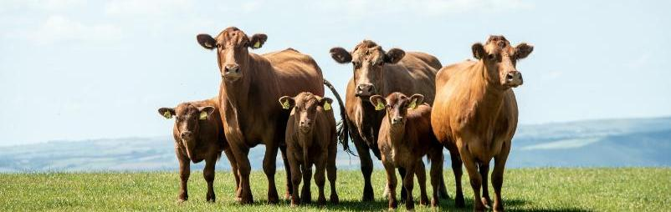

Cross-cutting themes

The first iteration of the roadmap identified three cross-cutting themes impacting progress in many areas, which will be considered as part of the roadmap process. These were:
Farm data. There are many advantages of real farm data over broad averages, not least the ability of individual farms to understand their impact and deploy relevant mitigations. Furthermore, real farm data allows modellers to better understand the baseline and the potential for improvement thereon. For example, we have no reliable baseline for the average digestibility/nutritional profile of grass forages or overall grassland utilisation in the UK.
Metrics for combining different GHGs into a single unit (such as GWP100) present challenges for agriculture. Unlike most other sectors of the economy, most emissions from farming are not carbon dioxide, and therefore the different methodologies can deliver different estimates of the relative impact of different mitigations, particularly in ruminant sectors.
Sequestration. Sequestration has been considered in the previous section. The remaining themes are explored below.

Farm data
Real UK farm data should underpin all theoretical models of mitigation. In practice, however, the availability of consistent, high-quality farm-level data remains limited. The variability between carbon calculators has been widely discussed in the 2022 Defra-funded study on harmonising carbon accounting tools. Since then, several leading calculators have worked together to reduce methodological divergence with some success. Even so, significant variability remains between individual beef and lamb farms, regardless of the calculator used.
In one large data set, the carbon footprint ranged from approximately 10 to 55kg CO₂e per kg deadweight. While part of this variation reflects structural characteristics that cannot easily be replicated, the scale of difference suggests that narrowing performance gaps between farms may offer greater mitigation potential than static modelling alone indicates.
This raises an important baseline question: where within this wide performance range does the modelled ‘baseline’ sit? This answer materially affects projected mitigation potential. If the baseline reflects relatively efficient systems, potential gains may appear smaller. If it reflects lower-performing systems, the scope for improvement may be underestimated.
The lack of high-quality farm-level baseline data on feed composition and intake in ruminants has been identified as a key area of uncertainty. The collection of a representative data set from commercial farms could be feasible and would improve both the National GHG Inventory and MACC modelling.
Current estimates of total managed grassland required for cattle and sheep are derived from modelled animal energy requirements, assumed diet composition based on industry averages and grass yield data from the National GHG Inventory. On this basis, the calculated grass area requirement is substantially lower than the total available grassland, even after areas used by horses, for example, are excluded. Rough grazing is not included in this assessment at all. This discrepancy suggests that underlying assumptions relating to diet composition, grass yield or utilisation may not fully reflect real-world conditions and warrants further investigation.
It should also be recognised that some modelling frameworks were originally developed to support National GHG Inventory reporting rather than farm-level decision making. Greater transparency around assumptions alongside continued strengthening of real-world farm data will improve confidence in baseline estimates and future projections.
This also points to an important opportunity for collective action across the sector. Large volumes of relevant data are already being generated through farm assurance, processor supply chains, carbon footprinting initiatives, advisory programmes and levy body activity. However, these data are often held in separate systems, collected for different purposes and are not easily combined. Improving the evidence base will therefore depend not only on collecting more data but on better connecting and using the data that already exist.
Future progress will depend increasingly on the ability of the sector to connect genetics, health, carcase, nutrition and environmental data across supply chains. Better integration between BCMS, processor feedback systems, breeding evaluations, carbon tools and farm benchmarking platforms could significantly strengthen the sector’s ability to monitor performance, target interventions and accelerate adoption of efficiency-focused measures such as improved liveweight gain and lower-emission breeding goals. Improving interoperability between systems and reducing duplication in data collection should therefore be viewed as a key enabling condition for future emissions reduction.

Industry initiative
Farm Data Exchange
Improving the quality of farm-level environmental data will be essential to strengthening future modelling, carbon accounting and practical decision making across the beef and lamb sector. One important step in this direction is AHDB’s Farm Data Exchange (FDE), which is designed to make better use of data already being collected across the industry.
The FDE aims to help connect and use data from multiple sources in a way that supports both farmers and the wider sector. This is important because large volumes of potentially valuable information already exist across supply chains, assurance schemes, levy activity, benchmarking programmes and commercial initiatives, but these data are often fragmented, inconsistent or difficult to combine.
Better data enhancement has the potential to improve the quality and representatives of farm-level baselines, strengthen future MACC modelling and inventory development, reduce duplication in data collection, improve benchmarking and decision support for farmers.
More information: Farm Data Exchange (FDE) | AHDB

Metrics
Metric choice is a cross-cutting issue for the Beef & Lamb Roadmap because methane is a short-lived climate pollutant, comprises around half of total emissions and a similar amount of the mitigation potential. Metric choice can influence the relative prioritisation of different mitigations and the relative cost per tonne of emissions abated. There is ongoing debate internationally about the most appropriate way to aggregate GHGs, particularly for short-lived methane.
For the purposes of this roadmap, the primary reporting framework remains aligned with National GHG Inventory practice to ensure comparability and consistency. At the same time, developments in warming-based metrics will continue to be monitored, recognising their potential influence on policy development and interpretation.
Questions around scope (Scope 1, 2 and 3 emissions), sequestration and accounting frameworks can create uncertainty and may affect uptake, particularly for those farm businesses at the forefront of emissions reduction. Soil carbon storage and on-farm sequestration remain important but challenging to measure consistently at scale. Policy and reporting frameworks are also evolving, creating a moving landscape for farmers and supply chains.
However, complexity does not prevent progress. The evidence is clear that improvements in soil management, nutrient efficiency, animal health and productivity can deliver measurable reductions in emissions intensity today while strengthening resilience and profitability. Many of these actions are system improvements rather than structural change, and they align environmental ambition with commercial performance.

Warming-based metrics
Insights from the Irish Agriculture MACC
The 2023 MACC for Irish Agriculture, produced by Teagasc, explored the implications of assessing mitigation using a warming-based metric. This work is relevant to the UK industry as the Irish beef sector operates under similar climatic conditions, faces comparable decarbonisation challenges and is evaluating many of the same mitigation measures.
The Irish Agriculture MACC 2023 assessed the same industry pathway comprising of 14 mitigation measures using both GWP100 and GWP*. The resulting curves illustrate how metric choice can influence the interpretation of mitigation potential. Key observations from the Irish analysis include:
- Under GWP*, the estimate of total warming from Irish agriculture since 2020 increased, reflecting historical changes in herd size
- The quantified impact of mitigation measures increased substantially from 2.9 Mt CO₂ to
8.3 Mt CO₂-we/yr
- The cost per kilotonne mitigated was decreased by approximately 60% under GWP*, as the same mitigation costs were spread over a larger quantified warming benefit
- The relative prioritisation of methane mitigation measures shifted slightly, with methane-focused interventions gaining prominence relative to some N₂O measures
- A greater number of mitigations measures could be considered ‘no-cost’ when prevailing carbon prices are considered
- More information: Marginal Abatement Cost Curve 2023 – Teagasc |

Latest research
Environmental trade-offs in UK beef production
This study examines environmental trade-offs in UK beef production using data from 28 breeder-finisher farms. It specifically explored whether reducing slaughter age consistently delivers lower climate impact when assessed using warming-based metrics.
The results showed that farms with a lower slaughter age did not automatically have the lowest overall warming impact. Performance was influenced by a combination of factors beyond finishing age alone.
The analysis compared three system types:
- Intensive systems (lowest slaughter age) tended to reduce methane emissions due to faster finishing, but they often exhibited higher emissions of long-lived gases such as CO₂ and N₂O, largely associated with greater use of concentrate feeds, cereals, soya and housing
- Mid intensity showed considerable variation, with examples of both high and low overall warming impacts
- Extensive systems (highest slaughter age) generally had lower input-related CO2 and N₂O emissions but higher methane intensities due to slower growth rates
Crucially, there was no simple linear relationship between slaughter age and total emissions intensity or warming. Some of the fastest-finishing farms recorded unexpectedly high warming impacts, illustrating that ‘intensification’ can shift emissions between GHG types rather than universally reducing total climate change.
The overall conclusion is not that reducing slaughter age is ineffective – it remains an important mitigation strategy – but that it should not be pursued in isolation. Improvements in finishing efficiency must be accompanied by attention to feed sourcing, nutrient management and system design to avoid unintended increases in CO₂ or N₂O.
This evidence reinforces a central message of the roadmap: effective mitigation requires a whole-system approach rather than optimisation of a single performance metric.
More information: Environmental trade-offs in UK beef production (2024) – AFN Network+

International perspective
Applying a warming-based approach in New Zealand and Uruguay
New Zealand and Uruguay are currently the only countries which have adopted split gas reporting for their national emissions targets. Such an approach still requires conversion to CO₂e for the purpose of reporting against international commitments, which may result in ambiguity between national and international targets; however, Uruguay also incorporates split gas reporting into its international targets.
New Zealand, which has a statutory climate framework similar to the UK’s, revised its 2050 agriculture methane target in December 2025, following advice from an international scientific panel. Applying a ‘no additional warming from methane’ principle, the Government adjusted its 2050 targets as follows:

- Reduced the biogenic methane emission: 14–24% reduction on the 2017 (from 24 to 47% set in 2019)
- Retained the 2030 methane target of 10% reduction (vs 2017)
- Retained the net zero target for long-lived gases
- Deferred decisions on the fourth emissions budget and considerations of revisions to earlier budgets until 31 December 2027
New Zealand’s international obligations under the Paris Agreement remain unchanged.
The UNFCCC requires signatories to report emissions using GWP100 but permits the use of alternative metrics in domestic policy design, as applied in this case. The UNFCCC has noted that while additional and marginal warming are broadly aligned for long-lived gases, this is not the case for short-lived gases such as methane, raising important questions about which warming information is most relevant for policy.
Uruguay has an overall target for methane emissions set at 818 Mt by 2035. It also has a specific target for the beef sector, with the aim of reducing intensity per unit of production by 35% by 2035 (relative to a 1990 baseline).
More information: A-proposed-approach-for-New-Zealands-adaptation-framework-final.pdf


Overcoming barriers and unlocking progress

The roadmap identifies priority mitigation measures capable of delivering meaningful reductions in emissions. The technical case is well established. However, achieving adoption at scale depends on more than scientific evidence alone.
Delivery requires practical feasibility, economic confidence, aligned policy frameworks and data integration. Progress against each mitigation measure depends on removing structural barriers and strengthening the conditions that enable farms to act with confidence.
Importantly, these barriers are rarely measure specific. The same constraints – fragmented data, delayed financial return, misaligned incentives or limited visibility of impact – affect multiple mitigations simultaneously. Likewise, many solutions unlock progress across several measures at once.
Effective delivery therefore requires coordination across advisory systems, policy mechanisms, assurance schemes and supply chains – not just technical guidance on individual interventions.

Barriers

Data fragmentation
Across genetics, health, soil and nutrient efficiency, data systems remain fragmented:
- Performance recording in beef is distributed across breed societies and platforms
- Soil testing and compaction monitoring are inconsistent
- Nitrogen data (fertiliser, manure and feed) are rarely integrated at whole-farm level
- Health impacts are often embedded in productivity data and hard to isolate
This limits benchmarking, reduces confidence and makes impact harder to demonstrate.

Economic risk and confidence
Many measures require upfront investment or behaviour change where returns are delayed (genetics), weather dependent (nitrogen optimisation), yield sensitive (legumes), or related to infrastructure (drainage). Without clear financial visibility, adoption slows.

Knowledge and behaviour
Awareness does not always translate into consistent practice. Confidence gaps, perceived risk and uncertainty around outcomes can limit adoption.

Policy and incentive misalignment
Where regulation, SFI and SFS options, assurance standards and supply chain requirements do not align, producers face mixed signals and increased compliance burden. Inconsistent signals can delay uptake even where measures are technically sound.

Infrastructure and system constraints
Some constraints are structural and cannot be solved by advice alone. Aging drainage systems, forage limitations and system-specific constraints can restrict the practical implementation of otherwise effective measures.

Limited visibility in carbon tools and benchmarking
Farmers and supply chains need to see credible, consistent evidence of impact. At present, visibility is constrained by inconsistent calculator assumptions and emission factors.

Cross-cutting enablers
Progress across all measures can be accelerated through coordinated action in the following key areas:
- Integrated data systems by linking genetics, health, soil and nutrient data into carbon tools and benchmarking frameworks
- Economic confidence by prioritising cost-saving measures and de-risking investment through schemes such as SFI and SFS and via the supply chain
- Policy alignment by better integration into policy mechanism and schemes, including partial funding to de-risk, e.g. SFI and SFS
- Practical demonstration by expanding demonstration farms and peer learning to convert evidence
into action

Future challenges
Responsible environmental management in cattle systems
As environmental expectations evolve, beef systems are likely to face increasing scrutiny around ammonia emissions, manure management and water quality.
This has already been the case, with the Government publishing its Water White Paper in January 2026, which set out its ambition to extend environmental permitting regulations to the cattle sectors. The beef sector recognises that maintaining public trust and market confidence will require continued improvement in environmental management alongside productivity gains. The beef industry is therefore in a great position to work together to implement an industry-led solution to air and water quality challenges, simultaneously taking responsibility but minimising business burden. The direction of travel is not simply about compliance with environment regulation, but it is about demonstrating that efficient beef systems, regardless of farm size or type, can operate responsibly within clear environmental limits. Good practice includes:

- Effective manure and slurry storage and utilisation
- Improved housing ventilation and ammonia mitigation
- Nutrient management planning and precision application
- Protection of watercourses and run-off control from sheds, fields and forage and manure stores
- Integration of environmental monitoring and farm data
- Use of best-available techniques, such as precision spreading fertiliser, where proportionate and practical
Many of these measures align closely with the efficiency-focused mitigation pathways already identified within this roadmap, particularly around nutrient use efficiency, soil management and animal performance. The roadmap therefore provides an opportunity for the sector to engage proactively with Defra and regulators on what a proportionate, evidence-based, industry-led solution as an alternative to environmental permitting could look like for beef systems in practice. This includes recognising the importance of maintaining viable domestic food production while continuing to improve environmental performance.
Future roadmap iterations could explore this area further, including case studies demonstrating how productivity, environmental compliance and lower emissions intensity can be achieved together.

Case Study
Responsible environmental management in a mixed beef and sheep system
Esther Rudge is a fourth-generation farmer, farming in partnership with her husband and son in Herefordshire. The family run a mixed farming enterprise, including beef sucklers, sheep, arable, fruit, renewable energy, firewood and glamping.
The farm has received national and local recognition for its environmental work, including winning Farmers Weekly Environmental Champion in 2020 and Wye Valley AONB Farm of the Year on three occasions.
Using Countryside Stewardship grants, the family have installed drains, concrete yards and repaired guttering on cattle sheds. This helps keep clean and dirty water separate. They also harvest rain water which the cattle prefer to mains water.
To protect waterways, they have built an attenuation pond, use electric fencing to keep cattle out of watercourses and have installed water troughs. Maize grown on the floodplain is undersown, and roadside fields have buffer strips to help reduce runoff risk.
These actions show how investment in drainage, yards, guttering, water management and field margins can reduce environmental risk while supporting livestock management.

Action plan 2026–2030

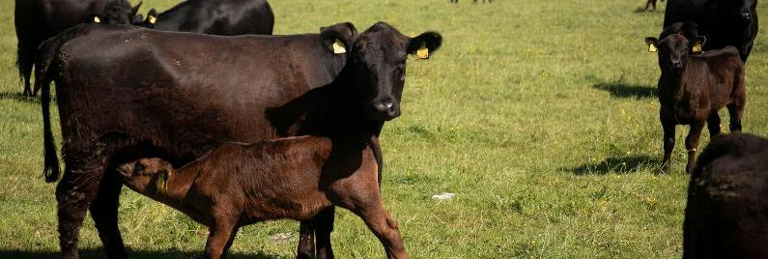

The action plan sets out the next phase of activity to support delivery of the Beef & Lamb Environmental Roadmap. It translates the roadmap’s priorities into practical areas for investigation, collaboration and implementation, recognising that progress will depend on continued innovation, partnership and evidence development. The plan is intended to be dynamic and responsive, adapting as new data, technologies and opportunities emerge, while maintaining a clear focus on improving environmental performance and strengthening the long-term resilience of the British beef and lamb sector. Delivery will depend on collaboration across producers, processors, levy bodies, researchers, government and other supply chain partners both in England and Wales. Many existing initiatives, including HCC’s Vision and associated sustainability programmes, already align strongly with the roadmap’s priority areas and will contribute to implementation, evidence generation and farmer engagement.

2026 | Establish baseline
Priority area | Key focus | Key output | Success measure | Who
Genetics and breeding | Establish baseline uptake of high-EBV sires/rams and environmental indexes | Published national baseline on EBV and Enviro index usage | % herds/flocks using high-EBV sires, % environmental index adoption | AHDB /Breed societies
Lifetime growth | Establish baseline optimum age at slaughter (suckler and dairy beef) | Published finishing age benchmark | National baseline for days to slaughter | AHDB/ HCC/ Processors
Health and welfare | Baseline endemic disease indicators and health planning uptake | Agreed metrics for BRD, lameness, fertility, mortality | % farms with structured health plan | AHDB/ HCC/RHW/ Vets
Soil health | Baseline pH, SOM, compaction risk (via SFI, SFS and surveys) | Soil condition benchmark report | % farms regularly soil testing | AHDB/HCC /Defra/WG
Grass–legume mix | Establish credible adoption baseline (SFI, SFS and survey triangulation) | Area estimated under legume swards | % grassland under legume/multispecies | AHDB/ HCC/ Industry
Nitrogen efficiency | Baseline fertiliser use, nutrient plan uptake, protected urea share | National N use baseline aligned to BSFP | kg N/ha baseline, nutrient plan uptake % | AHDB/HCC /AIC
Improved nutrition | Digestibility of grass and preserved forages | Robust farm data set for beef and sheep | Visibility of distribution and scope of potential improvement | AHDB/HCC /AIC

2027 | Accelerate adoption
Priority area | Key focus | Key output | Success measure | Who
Genetics and breeding | Promote environmental indexes and EBV confidence | National campaign + advisory integration | ↑ high-EBV sire use | AHDB/ HCC/ Breed societies
Lifetime growth | Improve forage quality and performance benchmarking | Best-practice toolkit published | ↓ average finishing age trend | AHDB /HCC
Health and welfare | Scale preventative health planning and diagnostics | Increased vaccine and diagnostic uptake | ↑ health plan compliance | AHDB/ HCC/ RHW
Soil health | Target liming and compaction management | Soil pH correction campaign | ↑ lime application rate | AHDB/ HCC/ CSF
Grass–legume mix | Align SFI and SFS options with livestock practicality | Increased legume establishment | ↑ area under clover | Defra/ WG/ AHDB/ HCC
Nitrogen efficiency | Expand nutrient planning and LESS adoption | Nutrient efficiency advisory push | ↑ protected urea share; ↑ LESS use | AIC/ AHDB /HCC
Improved nutrition | Increased digestibility of forages | Reduced enteric methane emissions | Improved average digestibility | AHDB/ HCC/AIC

2028 | Embed and incentivise
Priority area | Key focus | Key output | Success measure | Who
Genetics and breeding | Integrate Enviro indexes into carbon tools | EBV metrics embedded in at least one major carbon calculator | % carbon tools including genetics | AHDB/ Tool providers
Lifetime growth | Link finishing efficiency to supply chain messaging | Processor engagement framework | Supply chain reporting includes finishing age | Processors
Health and welfare | Integrate health metrics into carbon assessment | Health data linked to emissions benchmarking | Health indicators reported in carbon tools | AHDB/ Tool providers
Soil health | Expand drainage renewal and structured grazing | Drainage support guidance | ↑ uptake of soil improvement actions | Defra/WG/ Industry
Grass–legume mix | Demonstration farms and case studies | Published economic case studies | Farmer confidence metrics | AHDB/ HCC
Nitrogen efficiency | Pilot whole-farm N balance benchmarking | N balance pilot completed | Participating farms show reduced N surplus | AHDB/ HCC
Improved nutrition | Improved integration of forage, ration and performance data into carbon assessment tools | Nutrition data integration review completed with carbon tool providers | Number of tools reviewed, agreed recommendations for improved nutrition data use | AHDB/ HCC/AIC/ Carbon tool providers

2029 | Measure impact
Priority area | Key focus | Key output | Success measure | Who
Genetics and breeding | Quantify genetic contribution to emissions intensity | Annual EI reduction trend analysis | 0.1–0.2% annual EI reduction | AHDB
Lifetime growth | Measure national finishing age change | National performance update | % reduction vs 2026 baseline | AHDB
Health and welfare | Quantify disease-related productivity gains | Disease prevalence trend report | ↓ BRD, ↓ lameness prevalence | AHDB/ HCC/ RHW
Soil health | Report soil condition improvements | Soil monitoring update | ↑ % soils at optimal pH | AHDB/ HCC /Defra/WG
Grass–legume mix | Measure fertiliser displacement | Nitrogen savings estimate | ↓ synthetic N use on legume farms | AHDB/ HCC
Nitrogen efficiency | Report fertiliser use | National nitrogen efficiency update | ↓ kg N/ha without yield loss | AHDB/AIC
Improved nutrition | Measure progress in forage quality, ration planning and animal performance | Nutrition efficiency progress update | Clear evidence for future nutrition measures, including forage quality, ration balance, feed efficiency and methane related opportunities | AHDB/ HCC/AIC

2030 | Reset and next phase
Priority area | Key focus | Key output | Success measure | Lead
Genetics and breeding | Review adoption and update targets | 2026–2030 impact report | Majority of recorded herds using Enviro index | AHDB
Lifetime growth | Review finishing efficiency progress | Sector-wide efficiency report | Sustained ↓ finishing age | AHDB
Health and welfare | Review health planning and disease reduction | National health impact review | Demonstrable productivity gains | AHDB/ HCC/RHW
Soil health | Evaluate soil management progress vs policy ambition | Soil health progress report | Alignment with Defra 60% target | Defra/WG
Grass–legume mix | Assess stability and permanence of adoption | Legume retention assessment | Sustained area under legumes | AHDB/HCC
Nitrogen efficiency | Review nutrient efficiency and regulatory alignment | Nutrient strategy refresh | Continued downward N trend | AHDB/ HCC/AIC
Improved nutrition | Review nutrition progress and identify next-stage priorities | Nutrition and feed efficiency review | Clear evidence base for future nutrition measures | AHDB/ HCC/AIC

Annexe 1
Assumed adoption rates to 2050 for each mitigation measure (informed by the Beef & Lamb Environmental Roadmap Technical Steering Group).
Mitigation measure | Adoption rates
Sheep breeding for core traits | 80%
Sheep breeding for non-core traits | 25%
Lower emission breeding goal beef | 70%
Faster liveweight gain | 75%
Improved health – Beef | 80%
Improved health – Sheep | 50%
Improved nutrition | 50%
Soil compaction | 60%
Soil pH | 50%
Improved drainage | 20%
Grass–legume mix | 85%
Reducing N excess | 80%

Any enquiries regarding this publication should be sent to us at:

AHDB

Siskin Parkway East

Middlemarch Business Park

Coventry CV3 4PE

Email: info@ahdb.org.uk

Any enquiries regarding this publication should be sent to us at:

AHDB

Siskin Parkway East

Middlemarch Business Park

Coventry CV3 4PE

Email: info@ahdb.org.uk

Resources

† IMPORTANT NOTE: This 11% estimate is derived using the Global Warming Potential 100 (GWP100) metric which, like most emissions reporting in this area, combines various GHGs into a single Carbon Dioxide Equivalent (CO₂e) value. There are several alternative metrics which would create a significantly different view of the overall contribution of agriculture and livestock to UK emissions/warming.
‡ As calculated using GWP100.
§ Carbon dioxide warming equivalent (CO₂we) is a metric used to measure the climate impact of greenhouse gas emissions based on their actual contribution to global warming over time.
UN Framework Convention on Climate Change. 2016. The Paris Agreement. Article 2.
Climate Change Committee. 2020. The Sixth Carbon Budget. The UK’s path to Net Zero.
Climate Change Act (Northern Ireland) 2022.
Climate Change Committee. 2025. The Seventh Carbon Budget - Climate Change Committee
Defra, 2025. Agri-climate report 2024.
DESNZ. 2026. 2024 UK greenhouse gas emissions: final figures.
Poore and Nemecek, 2018. Reducing food’s environmental impacts through producers and consumers. Science, 360, 987-992. https://doi.org/10.1126/science.aaq0216
Beef and Lamb Environmental Roadmap. February 2025.
Pathak et al., 2022. Technical Summary. In: Climate Change 2022: Mitigation of Climate Change. Contribution of Working Group III to the Sixth Assessment Report of the intergovernmental Panel on Climate Change. https://doi.org/10.1017/9781009157926.002
IGD. 2025. Technical report: A net zero transition plan for the UK food system.
Capper et al., 2023. Helping farmers navigate the green economy: A data driven blueprint for net zero beef. Animal. 14, 2, 388-389. https://doi.org/10.1016/j.anscip.2023.01.515
AHDB. 2020. Beef feed efficiency programme.
Cooke, A. S., 2022. Rethinking efficiency: Growth curves as a proxy for inputs and impacts in finishing beef systems. Journal of Environmental Management, 324. https://doi.org/10.1016/j.jenvman.2022.116418
Kenny, D.A. et al., 2018. Improving feed efficiency of beef cattle – the current state and future challenges. Animal, 12(9), 1815-1826. https://doi.org/10.1017/S1751731118000976
ABP. 2025. PRISM Year 2 Report 2025
Davis, M.P. et al., J.E., 2014. Influence of dry matter intake, dry matter digestibility, and feeding behavior on body weight gain of beef steers. J. Anim. Sci. 92, 3018–3025. https://doi.org/10.2527/jas.2013-6518
Steen, R.W.J. et al., 2002. Effects of the proportions of high or medium digestibility grass silage and concentrates in the diet of beef cattle on liveweight gain, carcase composition and fatty acid composition of muscle. Grass Forage Sci. 57, 279–291. https://doi.org/10.1046/j.1365-2494.2002.00326.x
Van Middelaar, C.E., et al., 2013. Evaluation of a feeding strategy to reduce greenhouse gas emissions from dairy farming: The level of analysis matters. Agricultural Systems, 121, p9-22. https://doi.org/10.1016/j.agsy.2013.05.009
Lambert, M., et al., 2004. Advances in pasture management for animal productivity and health. N. Z. Vet. J. 52, 311–319. https://doi.org/10.1080/00480169.2004.36447
Murphy, D.J., et al., 2021. A review of precision technologies for optimising pasture measurement on Irish grassland. Agriculture 11, 600. https://doi.org/10.3390/agriculture11070600
AHDB. 2024. Farm standards review – Beef and Lamb.
Chen et al., 2016. The effect of lameness on the environmental performance of milk production by rotational grazing. Journal of Environmental Management. 172, 143-150. https://doi.org/10.1016/j.jenvman.2016.02.030
Fox et al., 2018. Ubiquitous parasites drive a 33% increase in methane yield from livestock. International Journal for Parasitology, 48, 1017–1021. https://doi.org/10.1016/j.ijpara.2018.06.001
Barnes et al., 2023. Improving Animal Health – Exploring GHG mitigation pathways. Report to Defra (RDE064).
MacLeod, 2023. The effect of an overall change in the health status of cattle, sheep and pigs on production and emissions. Unpublished technical note.
ADAS. 2013. Study to model the impact of controlling endemic diseases and conditions on national cattle productivity, agricultural performance and greenhouse gas emissions.
Skuce et al., 2016. Livestock Health and Greenhouse Gas emissions. Rapid Evidence Assessment. ClimateXChange.
Eory et al., 2020. Non-CO₂ abatement in the UK agricultural Sector by 2050. SRUC report for UK CCC 2020.
Capper, J.L. and Williams, P. 2023. Investing in health to improve the sustainability of cattle production in the United Kingdom: A narrative review. The Vet Journal 296-297. https://doi.org/10.1016/j.tvjl.2023.105988
Nieuwhof et al., 2008. The effect of footrot on weight gain in sheep. Animal, 2, 1427-1436. https://doi.org/10.1017/S1751731108002619
Kenyon et al., 2013. Reduction in greenhouse gas emissions associated with sustainable worm control in lambs. Agriculture, 3, 271-284. https://doi.org/10.3390/agriculture3020271
Small et al., 2017. Time to Vaccinate: Looking beyond antibiotics. MSD Animal Health.
Capper, J. and Williams P. 2019. Healthy livestock produce sustainable food. MSD Animal Health.
WHO. One Health
O’Neill, J. 2016. Tackling drug-resistant infections globally: final report and recommendations.
Capper. J.L. and Bauman, D.E. 2013. The role of productivity in improving the environmental sustainability of ruminant production systems. Annual Review of Animal Biosciences, 1, 469-489. https://doi.org/10.1146/annurev-animal-031412-103727
VMD. 2025. Veterinary Antimicrobial Resistance and Sales Surveillance 2024.
AHDB. 2023. Use of vaccines in cattle.
AHDB. 2023. Use of vaccines in sheep.
Ruminant Health and Welfare. Sheep Health and Welfare Strategy 2023 - 2028.
Ruminant Health and Welfare. Beef Welfare Strategy 2026 – 2031.
AHDB. EnviroBeef.
AHDB Signet Breeding Services, 2017.
Defra. 2023. Farm Practices Survey: Livestock Genetics and Breeding.
Signet. 2022.RamCompare year 6 results
Defra. 2025. Livestock feeding regimes and breeding practices.
AHDB. 2022. Beef feed efficiency programme
Farming Connect. Welsh Sheep Genetics Programme
AHDB. 2022. A vision for improving the beef and sheep sectors through animal breeding over the next 10 years.
Pulido-Moncada, M., et al., 2022. Soil compaction raises nitrous oxide emissions in managed agroecosystems. A review. Agronomy for Sustainable Development. 42, 38. https://doi.org/10.1007/s13593-022-00773-9
Zhang, B., et al., 2024. Soil compaction due to agricultural machinery impact: A systematic review. Land Degradation and Development. 35, 3256–3273. https://doi.org/10.1002/ldr.5144
Wang et al., 2018. Soil pH as the chief modifier for regional nitrous oxide emissions: New evidence and implication for global estimates and mitigation. Global Change Biology24 (2), 617- 626. https://doi.org/10.1111/gcb.13966
Dobbie & Smith, 2006. The effect of water table depth on emissions of N”O from a Grassland soil. Soil Use and Management, 22, 22-28. https://doi.org/10.1111/j.1475-2743.2006.00002.x
Professional Agricultural Analysis Group. 2023. Collation of data from routine soil analysis in the UK.
Rhymes, J., et al., 2021. Identifying barriers to routine soil testing within beef and sheep farming systems. Geoderma, 404, 115298. https://doi.org/10.1016/j.geoderma.2021.115298
Defra. 2025. Farm Practices Survey England 2025.
Jones, R. 2023. Optimising soil pH for the environment. CPM-magazine.
JNCC. 2025. UKBI - Agri-environment schemes
Defra, 2025. CS, ES and SFI option uptake data.
Emmett et al., 2010. Countryside Survey: Soils Report from 2007. NERC/Centre for Ecology and Hydrology (CS Technical Report No. 9/07, CEH Project Number: C03259).
Emmett et al., 2025. Environmental and Rural Affairs Monitoring and Modelling Programme (ERAMMP). ERAMMP Report 105: Wales National Trends and Glastir Evaluation. Report to Welsh Government (Contract C208/2021/2022) (UK centre for Ecology and Hydrology project 08435).
Sloman et al., 2024. England Ecosystem Survey: introducing England’s largest every field survey. Natural England.
Adcock et al., 2024. Mapping our natural assets: the Natural Capital and Ecosystem Assessment programme – Environment. Defra.
Defra, 2025. CS, ES and SFI option uptake data.
Defra, 2025. Farm practice survey: Grassland and grazing.
Defra, 2024. British Survey of Fertiliser Practice 2024 Annual Report.
Welsh Government, 2025. Sustainable Farming Scheme: Carbon Sequestration Evidence Review Panel. Review of further and alternative proposals to achieve carbon sequestration within the Sustainable Farming Scheme.
Defra. 2022. Harmonisation of Carbon Accounting Tools for Agriculture EVID4 – SCF0129.

